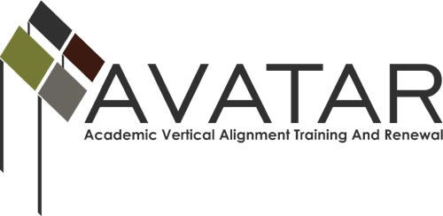

Action and Sustainability Plan – August 2013 to July 2014

ESC Region II

Date | Vertical Alignment Actions | Resources Required and Persons Responsible | Evidence of Implementation | Evidence of Impact
6/14/13 | Convene new team members for AVATAR training | Coordinator /training materials | Powerpoint materials | Team members prepared for AVATAR work
8/5/13 | Finalize vertical alignment partnerships | Coordinator | Team member names submitted | Team members contacted about AVATAR meeting
8/13/13 | Convene AVATAR team; discuss impact of the legislative session on mathematics | Coordinator/ESC partner | Agenda, minutes | Review of materials
9/24/13 | Convene team to collect and report institutional and regional data | Coordinator/each partner | Prepare and submit data | Discussion regarding data
10/9/13 | Provide information to counselors on the new Accuplacer examination | Coordinator | Presentation materials | Evaluation materials
10/23/13 | Provide AVATAR update at regional council meeting, including data points | Coordinator | Presentation materials | Discussion regarding data
10/29/13 | Convene team to review data for areas of possible misalignment | Coordinator/each partner | Agenda, minutes, data materials | Documentation of discussion points
11/6/13 | Provide Accuplacer information session for students | Coordinator | Session materials | Evaluation materials
11/19/13 | Convene team to discuss developmental education and new programs and strategies for student success | Coordinator/HE partner | Agenda, minutes | Documentation of discussion points
12/10/13 | Convene team to discuss math symposium topics, format, etc. | Coordinator | Agenda, minutes | Draft of math symposium program
1/14/14 | Convene team to discuss math symposium topics, format, etc. | Coordinator | Agenda, minutes | Draft of math symposium program
1/22/14 | Provide P-16 Council with an update of vertical team’s progress | Coordinator | Agenda, presentation materials | Discussion
2/12/14 | Convene higher ed/secondary ed mathematics teachers for Math Symposium | AVATAR Team | Program | Evaluation sheets
3/5/14 | Convene team to evaluate math symposium; review symposium evaluations; plan for following year | Coordinator/evaluation forms | Agenda, minutes, materials | Planning sheets
4/16/14 | Provide presentation to P-16 Council summarizing the work of the AVATAR Team | Coordinator | Program, powerpoint | Discussion
5/13/14 | Host 2013-14 AVATAR Team Celebration & discussion of next steps | Coordinator | Agenda, minutes, materials | Planning sheets
6/13/14 | Train 2014-2015 AVATAR team and sustain the regional partnership and vertical alignment work | Coordinator | Agenda, minutes, partnership forms | Sustained vertical alignment regional partnership
6/20/14 | Submit 2014-15 Regional Vertical Alignment Action and Sustainability Plan and accounting of fund expenditures | Coordinator | Action plan; expenditure summary | Materials submitted

