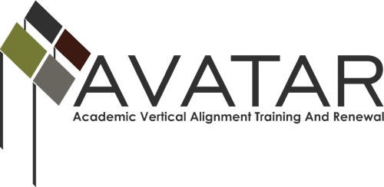

Final Report – September 2014 to August 2015

ESC Region ________Or Other Organization ____________________

Date of this report __________ (Due on August 14, 2015 –expenditures may be made through August 31, 2015)

- Members of Partnership
Please review the partnership listed on the AVATAR website http://www.untavatar.org/ . Is it accurate? ___ Yes ___No. If no, please indicate changes below. If your partners are not listed on the website, please provide a complete listing of your partners.

Name | District/University | Title | Email | Phone

- Executive Summary
- The purpose of the College Preparatory Course Project of AVATAR is to strengthen regional secondary and postsecondary partnerships to create and document the development of vertically aligned English Language Arts and Mathematics college preparatory courses pursuant to House Bill 5 (HB5), 2013 83rd Texas Legislative Session. This project had two goals:
  - 1. Enhance the success of students who complete College Preparatory Courses in graduating college-ready from high school and making smooth transitions to postsecondary education without the need for developmental education.

  - 2. Determine best practices in development and delivery of College Preparatory Courses as defined by HB5 in view of regional characteristics and needs.

- You agreed to develop CPCs with your partners in ELA and Math through a vertical alignment process engaging secondary and post-secondary institutions so that high school students are prepared to enroll and succeed in postsecondary education. Additionally, you committed to evaluate CPCs developed by your regional partnership based on the success of local students, emerging practice around the state, and the characteristics and needs of the region and its population.

Below please prepare your one-page, single spaced narrative. Please describe the extent to which you have achieved each of the stated goals of the project. By highlighting your outcomes, successes, and challenges. Please list all meetings, trainings, and events you hosted August 14, 2014 – August 31, 2015

State Each Goal and Highlight Your Outcomes, Successes, and Challenges:

Please list all meetings, trainings, and events you hosted August 14, 2014 – August 31, 2015 (Include dates, number of attendees, & outcomes)

- What do you view as the primary accomplishments of the work in 2014-15 with the CPCs?

- What would you do differently with your CPCs work, if you had it to do over again?

- How could the AVATAR staff be of greater help to you?

- How do you plan to assess the impact of the CPCs on students’ success in college?

- Final Expenditure Report
For each budget category, please list the amount expended.
Budget Category | Briefly Explain Expenditures | Amount Budgeted | Total Expended as of 8/15/2015 | Total Anticipated Expended by 8/31/2015
Personnel costs
Travel
Materials
Food
Consultants/Stipends
Other
TOTAL

Comments:

Thank you so very much. Please send to: Claudette.Jenks@THECB.state.tx.us or Jean.Keller@unt.edu

