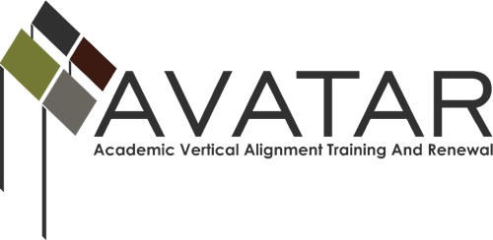

Final Report – May 2015 to August 2016

ESC Region ________Or Other Organization ____________________

Date of this report _____________________________________________

- Members of Partnership
Please review the Partnership listed on the AVATAR website. Is it accurate? ___ Yes ___No If no, please indicate changes below.

Name | District/University | Title | Email | Phone

- Executive Summary
In a one-page, single spaced narrative, please describe the extent to which you have achieved each of the stated goals of the project. Highlight your outcomes, successes, and challenges.

- What do you view as the primary accomplishments of the work in 2015-16?

- What problems or barriers have you faced in completing the project?

- Final Expenditure Report
For each budget category, please list the amount expended.
Budget Category | Amount Budgeted | Total Expended as of 8/15/16
Personnel costs
Travel
Materials
Food
Consultants
Other
TOTAL

- Action Plan for Continuation in 2016-17
Goals of partnership (Sample goals below. Please replace them with yours.)
- Develop ISD and post-secondary partnerships appropriate to local endorsement options
- Facilitate offering of College Preparatory Courses (CPCs) of the partnership
- Deepen vertical alignment of the ELA offerings of ISD and post-secondary partners

Objectives supporting your goals
1.
2.
3.

Plan of Work
# of Related Objective(s) Above | Activity | Planned Evidence of Implementation | Planned Evidence of Impact

Timeline, Responsibility, Resources, and Evaluation
Date | Activity | Who is Responsible | Resources Needed | Associated Evaluation

