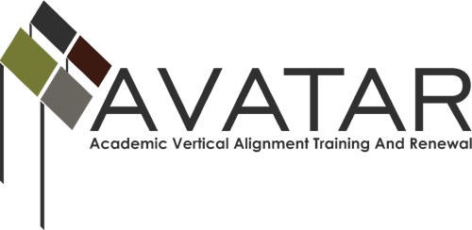

Mid-term Status Report – May 2015 to December 2015

ESC Region ______

Date of this report _______________________________________________

Due on or Before December 31, 2015

- Members of Partnership
Please list all partnership team members by name, affiliation, title, email and phone number.

Name | District/University | Title | Email | Phone

Please identify members of your active Vertical Alignment Teams with name, affiliation, title, e-mail address, and phone number.

Name of VAT____________________________
Name | District/University | Title | Email | Phone

Name of VAT____________________________
Name | District/University | Title | Email | Phone

Name of VAT____________________________
Name | District/University | Title | Email | Phone

- 2015-16 Goals of the Partnership. Please note any modifications from the Action Plan.

- Status of Plan of Work

Please list the objectives associated with your goals in the table below and state the activities that have taken place to further each objective. State the results of each activity and any follow-up actions required to meet your objective.

Objectives | Activities | Results/Impact and Follow-up Anticipated

- What challenges or obstacles have you encountered and what have you done to overcome them?

- What assistance would be helpful to you?

- Expenditure Report
For each budget category, please list the amount expended to date.
Total Budget Allocation:: $_________________
Budget Category | Expended by December 2015 | Anticipated Expenditures by August 30, 2016
Personnel costs
Travel
Materials
Food
Stipends to partners
Other
TOTAL

