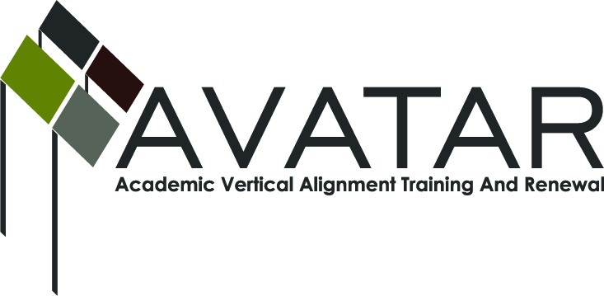
AVATAR Partnership Region: 9
Meeting/Session Documentation Form

Form should be completed after each meeting and given to the Regional AVATAR Coordinator/Facilitator
Meeting: | Math AVATAR Team
Meeting Purpose: | Project Focus for 2013-14
Date: | October 24, 2013 | Start Time: | 4:30 p.m. | End Time: | 5:30 p.m.
Meeting Coordinator/ Facilitator: | Christina Hoffmaster | Location: |  | Jack Room- Region 9 Education Service Center
Meeting Recorder: | Christina Hoffmaster | Meeting Timekeeper: |  | Christina Hoffmaster

Time | Topic | Format | Discussion Leader | Desired Outcome
4:30 | Update on P-16/Gen Tx conference | P | Cheryl Sigel | Information shared with team members
4:45 | Group discussion on past projects and effectiveness | W | Christina Hoffmaster | Select projects with greatest impact for teachers and students
5:00 | Focus on two team projects for the year | D, W | Christina Hoffmaster,  Paula Whitmire | Plan for expenditures and implementation of projects
Agenda Format Key: P = Presentation, F = Feedback, D = Decision-Making, W = Work Group, O = Other, with explanation

AVATAR Meeting Minutes

Action Item | Person Responsible | Due Date
Continue with campus visits to area schools by Vernon College math professors to share the need for math skills in the work place and for college | Paula Whitmire | Spring Semester-2014
Implement a group study of the book, Lesson Study Step by Step: How Teacher Learning Communities Improve Instruction by Jacqueline Hurd & Catherine Lewis.  Region 9 will purchase books for study with AVATAR funds. Teachers will use Algebra 1 and AQR as the focus for their book study and create lessons to share with teachers who teach these 2 subjects. Project will be tweaked and repeated as a summer workshop for teachers. | Christina Hoffmaster | Spring Semester-2014  Summer Workshop-2014
Notes
Meeting Participant List

Name | Title | Organization/Institution
Christina Hoffmaster | Math Instructor | Vernon College
Paula Whitmire | Math Instructor | Vernon College
Cheryl Sigel | Math Teacher | Vernon High School
Mona Pelkey | Curriculum Director | Vernon ISD
Ward Roberts | Curriculum Director | WFISD
Lezli Boren | Math Teacher | Hirschi HS

