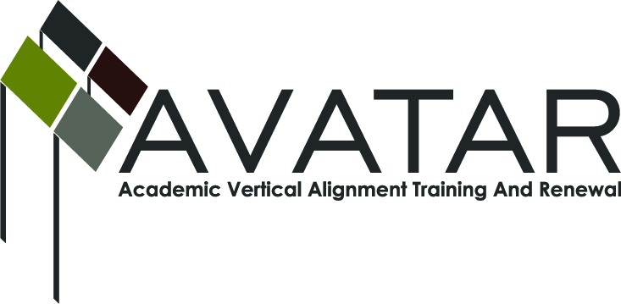
AVATAR Partnership Region: 2
Meeting/Session Documentation Form

Form should be completed after each meeting and given to the Regional AVATAR Coordinator/Facilitator
Meeting: | AVATAR Team Meeting
Meeting Purpose: | Focus of Work; Symposium Planning
Date: | November 4, 2013 | Start Time: | 3:00 p.m. | End Time: | 4:30 p.m.
Meeting Coordinator/ Facilitator: | Janet M. Cunningham | Location: |  | STAR Annex
Meeting Recorder: | Janet M. Cunningham | Meeting Timekeeper: |  | Connie Nowell

Time | Topic | Format | Discussion Leader | Desired Outcome
3:10 p.m. | Welcome | Discussion | Janet Cunningham
3:12 p.m. | Discussion Items | Discussion | Janet Cunningham
3:40 p.m. | Mathematics Symposium | Discussion | Janet Cunningham | Organize sessions/presenters
3:56 p.m. | Next Meeting | Discussion | Janet Cunningham | Set date
Agenda Format Key: P = Presentation, F = Feedback, D = Decision-Making, W = Work Group, O = Other, with explanation
AVATAR Meeting Minutes

Action Item | Person Responsible | Due Date
Discussion Items:  - Campus, Region, State Data Reports  - Legislative/Curriculum Updates  - State AVATAR Meeting  - TSI Assessment  Dr. Silva distributed the November 4, 2013, issue of Texas Education News which contained new dual credit course rules as required by HB5 and SB31.  There followed a discussion of the TSI assessment. Professor Tintera shared with the group the outcome of Texas A&M University-Corpus Christi’s early TSI exams. He shared that one-half to two-thirds of the students who took the test placed as ABE students. Dr. Silva informed the group that some Calallen High School students have taken the test which was administered by Del Mar College. Those students have not yet received their results.  Dr. Silva presented a curriculum update on a collaborative consortium, headed by Lead Forward, which will include 22 school districts and run over a three year period. Calallen, Gregory-Portland, and Aransas County School Districts will write curriculum over three separate sessions and will then disseminate their plans to the other 19 districts.  Dr. Cunningham reported that the state AVATAR meeting was held by conference call; the partner who was to relate the findings of the call was not present at this meeting. | All members should complete the demographic spreadsheet which Dr. Cunningham will be forwarding to them | October 28, 2013
Mathematics Symposium - February 12 at ESC from 9:00 a.m. to 3:00 p.m. There was a general discussion regarding the structure of the symposium, sessions which would be of interest to both college professors and high school teachers, and presenters for those sessions, as well as who should be invited to attend. Some suggestions for sessions included panel discussions with professors and teachers, an update on TSI, a discussion on college/career readiness standards, what to do after CSCOPE (Dr. Silva’s collaborative), an update on HB5 and SB31, and plans for developmental education. It was suggested that a panel discussion with first year college students relating their college readiness might be appropriate. | Members should continue to think about possible sessions and presenters. | October 28
Next meeting – Monday, November 18, at 3:10 p.m., STAR Annex, 4201 Calallen Dr., Room D-9. A second meeting was set for December 16 at 3:10 p.m., also at STAR Annex. | Dr. Janet Cunningham
Notes

Meeting Participant List

Name | Title | Organization/Institution
Dr. Melana Silva | Curriculum Specialist | Calallen ISD
George Tintera | Professor | Texas A&M University-CC
Dr. Janet M. Cunningham | Executive Director | Education to Employment Partners (P-16 Council)

