FAQ for AVATAR College Preparatory Course Project

What is the work of an AVATAR CPC coordinator? (12/9/2014)
A coordinator guides the collaborative development of College Preparatory Courses (CPCs) as defined in HB5 and the agreements related to their offering by ISDs. Although some AVATAR coordinators work with partnerships that include all school districts in a region, this is not required by the project. There is need to identify a partnership that includes at least one ISD, one 2-year college, one 4-year college, and a P-16 Council and, within it, Vertical Alignment Teams (VATs) for ELA and Mathematics. The VATs develop course curriculum by discipline; the partnership agrees to Memoranda of Understanding (MOUs) for the offering of CPCs by the ISDs. The coordinator guides the partnership and its subgroups by facilitating critical conversations about the vertical alignment needed to promote student readiness and success, helps to keep the partnership moving toward its goals, and manages the resources associated with the project.
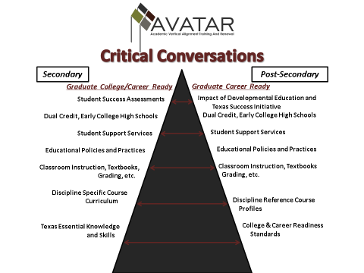

There is variation in work with CPCs across the state, with ISDs in some regions already offering CPC courses and ISDs in other regions just beginning to learn about this mandate of HB5. The work of beginning partnerships is to develop syllabi and related MOUs for fall offering of courses that will well serve local students. If your partnership is already in place, the work may include removing barriers to implementation of CPCs or study of evidence of the readiness and success of 2014-15 students to promote better alignment of the curriculum.

How do regions generally spend their grant money for vertical alignment? (12/1/2014)
Grant funds are commonly used for meeting expenses such as food and resource materials, stipends or substitute pay for ELA and Mathematics VAT participants, salary and fringe benefits for specialists, travel to meetings or related conferences, and professional development expenses such as speakers and materials. Exxpenditures should be identified with collaboration to develop and improve vertical alignment of CPCs.

Must all the listed members of a partnership (ISD, 2-year college, 4-year college, P-16 Council) be included? (12/9/2014)
- P-16 Councils may not exist in every community, leading to need to find other workforce partners.

- It is desirable that a partnership represent a genuine feeder pattern so that participants recognize they share the same students. To assess whether potential partners represent a feeder pattern, you may check the data as follows.

To find out where students from a given high school attend college, go to the Data Resources and Tools section of the Texas Higher Education Coordinating Board (THECB) website. Go to the High School to College (P-16) section in the upper right-hand corner, and click on High School Graduates in Higher Education. Then enter High School Graduates Enrolled in Higher Education the Following Fall by High School County, School District, High School. Select your year, county, and high school.

You can learn about transfer students within public higher education by looking at reports on Academic Performance of Transfer Students. These four-page reports are available for 2-year and 4-year colleges. To get them, go to the Success menu on the THECB Data Resources and Tools website, and enter Transfer Students’ Success
If your institution of interest is a receiver of transfer students, you may view their GPA ranges and retention rates by sender institution for various categories of student such as those who were enrolled or not enrolled in Developmental Education, those who completed AA and TA degrees at their first institutions, those who left their first institutions having completed the core curriculum, those who met field of study requirements at their first institutions, and those who did or did not complete certificates.

- Finding the right contact at an institution of higher education may be difficult. People with titles like provost, vice president for academic affairs, or director or dean of a college that includes the core curriculum are good first choices. If you are having trouble making a contact, we may be able to help. Private as well as public colleges may be involved if they receive students from the high schools of participating ISDs.

Is it possible for Vertical Alignments Teams to get a report of responses to the items on the Texas Success Initiative (TSI) assessment of students in a particular ISD? (12/9/2014)
Claudette Jenks from the THECB responded. She affirmed that the ISD test administrators have access to the data and can run a report.

If any team would like instruction on how their test administrator can run the reports, they may contact:
Chantel Reynolds
Senior Director of ACCUPLACER State & Policy Initiatives
College Board
45 Columbus Avenue
New York, NY 10023
512.636.1436
212.253.4061
creynolds@collegeboard.org

It is advised that teams start with the test administrators, but you may also contact at THECB :
Dr. Alan Bugbee
(512) 427-6244
Alan.Bugbee@thecb.state.tx.us

Dr. Bugbee can provide information regarding the reports as well.

What are the beginning and ending dates of the regions’ subcontracts for development of College Preparatory Courses? (12/11/2014)
The 11 regions that have been part of AVATAR in the past received their funding for the CPC Project as amendments to earlier AVATAR grants from the THECB. Dates of these subcontracts may vary. Please address your request for information to
Claudette Jenks
Assistant Director
Division of P-16 Initiatives
Texas Higher Education Coordinating Board
1200 East Anderson Lane
Austin, TX 78752
(512) 427-6529 office
(512) 427-6444 fax
Claudette.jenks@thecb.state.tx.us

Nine of the regions are receiving subcontracts from UNT, which received $100,000 from THECB for this purpose. For these regions, the starting date of the subcontracts is November 15, 2014, and the ending date is August 15, 2015.

Who should receive monthly expenditure reports related to these AVATAR Projects? (12/9/2014)
Grantees in the original 11 regions should send the monthly reports to Dr. Booker (Jerel.Booker@thecb.state.tx.us ) with a copy to Claudette Jenks. The nine regions that have subcontracts with UNT do not file monthly reports but will submit a final financial report.

