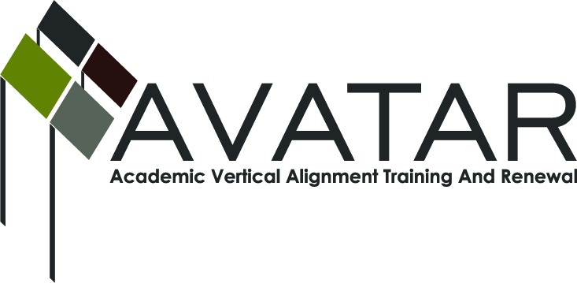
AVATAR Partnership Region: 2
Meeting/Session Documentation Form

Form should be completed after each meeting and given to the Regional AVATAR Coordinator/Facilitator
Meeting: | AVATAR Team Meeting
Meeting Purpose: | Focus of Work; Symposium Planning
Date: | February 10, 2014 | Start Time: | 3:10 p.m. | End Time: | 4:40 p.m.
Meeting Coordinator/ Facilitator: | Janet M. Cunningham | Location: |  | STAR Annex
Meeting Recorder: | Janet M. Cunningham | Meeting Timekeeper: |  | Connie Nowell

Time | Topic | Format | Discussion Leader | Desired Outcome
3:10 p.m. | Welcome | Discussion | Janet Cunningham
3:15 p.m. | Payments for Fall | Presentation | Janet Cunningham
3:20 p.m. | Discussion Items | Discussion | Janet Cunningham | Finalize math symposium program
4:38 p.m. | Next Meeting | Discussion | Janet Cunningham | Set date
Agenda Format Key: P = Presentation, F = Feedback, D = Decision-Making, W = Work Group, O = Other, with explanation
AVATAR Meeting Minutes

Action Item | Person Responsible | Due Date
Discussion Items:  - Mathematics Symposium  Dr. Cunningham presented the program for last minutes suggestions/changes. Questions for students were suggested for the early panel discussion. A general discussion of the remainder of the morning sessions followed to include names, content and presenters for each session. Dr. Silva agreed to join the lunch panel. Afternoon breakout sessions were then discussed. Dr. Cunningham will revise resend the flyer so that members can redistribute. It was decided that participants would be asked at the beginning of the symposium to jot down questions during the day to be discussed at the final session.  - Legislative/Curriculum Updates  Information is trickling in; will watch daily.  - College Readiness Course  There was a general discussion of how this course will work. This course must be in place for the upcoming school year. Should the AVATAR team need to form a group to assist in moving this forward? The Education Service Center will take the lead.  - Counselor Conference  Melissa Morin with check with the ESC to see if it plans to hold a conference this year. Our AVATAR team will assist in any way it can. Dr. Cunningham informed the group that AVATAR would be expanding next year to include ELA. | Dr. Cunningham will email flyer for distribution and will finalize presenters. All members should publicize event.  Melissa Morin will check with the ESC on its plans to host a counselor conference this year. | February 11, 2014
Payments for Fall | Dr. Cunningham distributed stipends to members who were present.
Next meeting – Thursday, February 20 – Math Symposium; Monday, March 3, at 3:10 p.m., STAR Annex, 4201 Calallen Dr. | Dr. Janet Cunningham
Notes

Meeting Participant List

Name | Title | Organization/Institution
George Tintera | Associate Professor | Texas A&M University-CC
Dr. Melana Silva | Curriculum Coordinator | Calallen ISD
Dr. Janet M. Cunningham | Executive Director | E2E Partners (P-16 Council)
Melissa Morin | Research & Planning | ESC-2
Carlos Guerrero | Instructional Coach | Robstown ISD
Paul Johnson | Math Instructor | Del Mar College
Toni Norrell | Math Specialist | ESC-2

