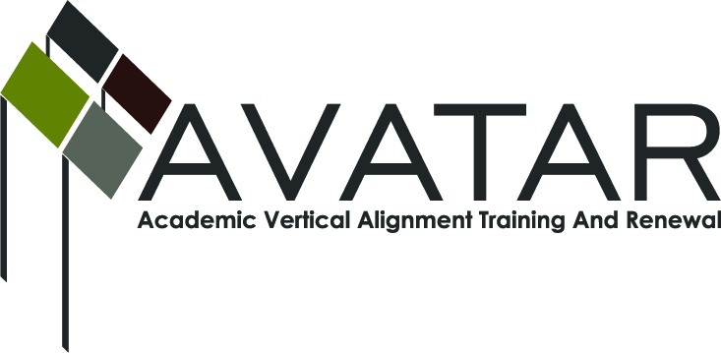
AVATAR Partnership Region: 2
Meeting/Session Documentation Form

Form should be completed after each meeting and given to the Regional AVATAR Coordinator/Facilitator
Meeting: | AVATAR Team Meeting
Meeting Purpose: | College Preparatory course
Date: | May 20, 2014 | Start Time: | 4:00 p.m. | End Time: | 6:45
Meeting Coordinator/ Facilitator: | Janet M. Cunningham | Location: |  | STAR Annex
Meeting Recorder: | Janet M. Cunningham | Meeting Timekeeper: |  | Connie Nowell

Time | Topic | Format | Discussion Leader | Desired Outcome
4:00 p.m. | Welcome | Discussion | Janet Cunningham
4:15 | College Preparatory Course | Discussion | Janet Cunningham | Syllabus for course
6:45 p.m. | Adjourn
Agenda Format Key: P = Presentation, F = Feedback, D = Decision-Making, W = Work Group, O = Other, with explanation
AVATAR Meeting Minutes

Action Item | Person Responsible | Due Date
College Preparatory Course:  Dr. Cunningham presented a revised draft of the MOU to be presented to area superintendents at a meeting at the Service Center on May 21.  The IHE members discussed the objectives to be covered in the course and then turned their attention to the development of a draft course syllabus. They reviewed the individual institutions’ DE syllabi, TEKS standards, College and Career Readiness standards, and areas covered on the TSI. Dr. Tinterra will incorporate the changes and pass it along to Dr. Cunningham, who will present it to the LEA members at their meeting on Wednesday, May 21.  There was discussion of what the IHEs do in their DE courses to ensure student success and a possible way to incorporate such measures into the syllabus.  There was also discussion led by Melissa Morin, ESC2, concerning feedback she had received from area LEAs and how best to respond to their concerns.  Everyone was invited to attend a very important meeting at the ESC2 concerning HB5 and its mandate to offer this course at the beginning of the 2014 school year. | AVATAR IHE members  Dr. George Tinterra | May 21, 2014
Next meeting – Wednesday, May 21, at 4:00 p.m., STAR Annex, 4201 Calallen Dr. | Dr. Janet Cunningham | May 21, 2014
Notes

Meeting Participant List

Name | Title | Organization/Institution
Dr. Janet M. Cunningham | Executive Director | E2E Partners (P-16 Council)
Paula Kenney-Wallace | Division Chair | Coastal Bend College
Melissa Morin | Research & Planning | ESC-2
Polly Allred | Math Instructor | TAMU-Kingsville
Paul Johnson | Math Instructor | Del Mar College
George Tinterra | Associate Professor | TAMU-Corpus Christi

