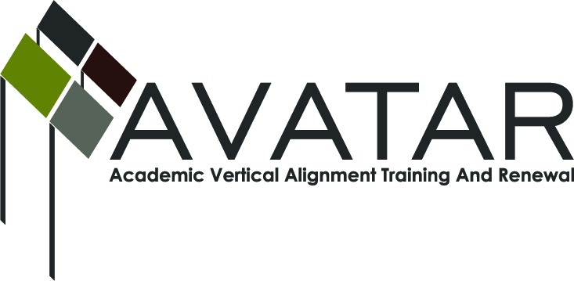
AVATAR Partnership Region: _______12___________
Meeting/Session Documentation Form

Form should be completed after each meeting and given to the Regional AVATAR Coordinator/Facilitator
Meeting: | HOT P-20 Regional General Council Meeting
Meeting Purpose: | AVATAR Update, Business and Industry Panel Presentation
Date: | 12/19/12 | Start Time: | 8:30 a.m. | End Time: | 10:30 a.m.
Meeting Coordinator/ Facilitator: | Christine Holecek | Location: |  | Waco ISD Board Room
Meeting Recorder: | Sheryl Kattner-Allen | Meeting Timekeeper: |  | Sheryl Kattner-Allen

Time | Topic | Format | Discussion Leader | Desired Outcome
8:30 | Welcome from Waco ISD | P | Bonny Cain | Welcome
8:35 | Business and Industry Panel Presentation | P | Dr. Harold Rafuse | Presentation by members of the Waco Business League
9:15 | Greater Waco Manufacturing Academy | P | Donna McKethan | Overview of new Business Partnership with the GWMA
9:45 | Overview of College and Career Readiness with a business input | P | Jeni Janek | Discussion of business involvement P-20 initiatives
10:10 | AVATAR update | P | Chris Holecek | Gave a list of the team members and the AVATAR Action plan for spring 2013
Agenda Format Key: P = Presentation, F = Feedback, D = Decision-Making, W = Work Group, O = Other, with explanation

AVATAR Meeting Minutes

Action Item | Person Responsible | Due Date
Next Meeting Date and Location TBD | Eunice Williams-HOT Workforce Solutions | December 31
Next AVATAR team meeting | Dr. Fred Hills, McLennan Community College | February 8th
Create online collaborative site | Londa Carriveau, McLennan Community College | January 2013
Notes
Bring AVATAR update to the next General Council Meeting on March 6, 2012

- Sign in Sheet attached
Meeting Participant List

Name | Title | Organization/Institution

