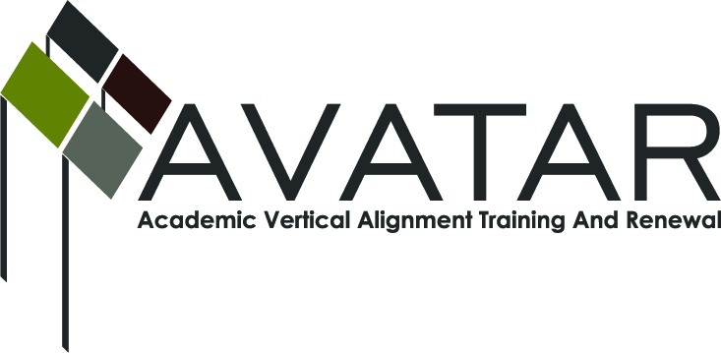
AVATAR Partnership Region: ESC Region 13
Meeting/Session Documentation Form

Form should be completed after each meeting and given to the Regional AVATAR Coordinator/Facilitator
Meeting: | ACC Highland Campus Avatar
Meeting Purpose: | Review action plan and determine content/agenda for training
Date: | 3-5-13 | Start Time: | 5:00 pm | End Time: | 6:00
Meeting Coordinator/ Facilitator: | Susan Diaz | Location: |  | Region 13
Meeting Recorder: | Jennifer Drumm | Meeting Timekeeper: |  | Jennifer Drumm

Time | Topic | Format | Discussion Leader | Desired Outcome
5:00-5:20 | Proposals for project components | w | Jennifer | Review proposals, set tasks and time lines to support project completion deadlines  Dates to stay away from:  Finals for ACC – May 6-10  Potential  May 3rd?
5:20 – 6:00 | Workshop; input and potential agenda items | w | Susan | Continue discussion from last meeting (below) and add more detail:  Wendy would present her findings on college readiness. We discussed synthesizing information that is already out there like the Framework in order to further college readiness and STAAR success. Workshop would be f2f before being turned into online components. Each person would take on a one hour piece and the presentation and then we would have a q and a session at the end.  John—non-fiction  Stacia—soft skills  Wendy—findings from article  Susan—EOC  Moriah—Framework, WAW, self-assessment.  Update:  Susan – test / history and evolution  Wendy – data  Stacia – soft skills / behavioral problems  John – Weekly writing, project in chunks  Moriah – self assessment survey  9:00 – 4:00  45 minute chunks  9:00 – welcome  9:15 – Susan  10:00 – 10:10 – break  10:10 – 10:55 – Wendy  11:05 – 11:55 – Break  11:05 – 11:50 – Stacia  11:50 – 1:00 – Lunch  1:00 – 1:45 – John  1:45 – 2:00 – Break  2:00 – 2:45 – Moria  3:00 – 3:30 – Round Table  3:30 – 4:00 – Round Table Discussions - based on each topic with activities and/or additional information  May 3rd  Possible debrief on May 3rd after the session  Possible – survey and note taking guide to use on the day of the session  Print – April 24th  Presentation materials – April 24th  June 3rd – materials revised for web site
Other | Next meeting – last planning before May 3rd |  |  | April 24th at 5:00 pm ACC
Agenda Format Key: P = Presentation, F = Feedback, D = Decision-Making, W = Work Group, O = Other, with explanation

AVATAR Meeting Minutes

Action Item | Person Responsible | Due Date
Rooms – is COW day happening at ESC13 on May 3rd?  No – we have a room reserved at Region 13 and parking will not be an issue | Jennifer
Gary – reserve a room at Eastview – multi-purpose room  No need to do this as we have access to the rooms at Region 13 | Gary
Video for May 3rd? | Jennifer & Susan
Reserve room for April 24 | Gary
Contracts and forms needed for vendors | Jennifer
E-Campus and reserve room for May 3rd | Jennifer & Susan
Notes

Meeting Participant List

Name | Title | Organization/Institution
Susan Diaz | Literacy Specialist | Region 13
Wendy Lym | Professor, Associate | Austin Community College
I. Moriah McCracken | Assistant Professor of English Writing & Rhetoric | St. Edwards University
Gary Madsen | Director, P-16 Initiatives | Austin Community College
Stacia Bowley | English IV Teacher | L.C. Anderson High School
Jennifer Drumm | Senior Coordinator, Curriculum & Instruction | ESC Region 13

