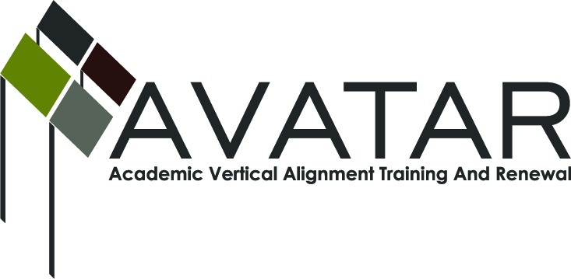
AVATAR Partnership Region: 2
Meeting/Session Documentation Form

Form should be completed after each meeting and given to the Regional AVATAR Coordinator/Facilitator
Meeting: | AVATAR Team Meeting
Meeting Purpose: | Discuss goals of the team; develop preliminary action plan
Date: | September 12, 2012 | Start Time: | 7:30 a.m. | End Time: | 9:15 a.m.
Meeting Coordinator/ Facilitator: | Janet M. Cunningham | Location: |  | Northwest Center for Advanced Studies
Meeting Recorder: | Janet M. Cunningham | Meeting Timekeeper:

Time | Topic | Format | Discussion Leader | Desired Outcome
7:30 a.m. | Welcome and Introductions  Discuss goals of AVATAR project | Presentation | Janet Cunningham
7:45 a.m. | Review norms/expectations  Review Team Building presentation | Presentation | Janet Cunningham
8:00– 9:15 | Discuss goals of the partnership  Review data; visit college algebra classroom; discuss system differences | P, D, W  O-classroom visit | Entire team
Agenda Format Key: P = Presentation, F = Feedback, D = Decision-Making, W = Work Group, O = Other, with explanation

AVATAR Meeting Minutes

Action Item | Person Responsible | Due Date
After reviewing data, the team discussed additional data they would like to see, including information about college readiness rates. This information will be added to the data presentation. | Janet Cunningham | September 29, 2012
The team discussed system differences, such as the use of calculators. Students are required to use calculators in high school classes, but may or may not be able to use them in college classes and on placement tests. There needs to be a greater awareness of the requirements for each assessment. Janet will bring in examples of the different tests to the next meeting. | Janet Cunningham | October 17, 2012
Also for the next meeting, there will be a review of the College and Career Readiness Standards and a discussion regarding the new state mathematics standards. | Janet Cunningham | October 17, 2012
Notes
Meeting Participant List
Name | Title | Organization/Institution
Dr. Melana Silva | P-12 Math/Science Teacher | Calallen ISD
Sandra Rippstein | Secondary Mathematics Teacher | Calallen ISD
Faye Wilson | Secondary Mathematics Teacher | Calallen ISD
Paul Johnson | Math Instructor | Del Mar College
Dr. Faye Bruun | Assistant Professor, Department of Curriculum and Instruction | Texas A&M University Corpus Christi
Toni Norrell | Mathematics Curriculum Consultant | Education Service Center, Region 2
Melissa Morin | Research, Planning, and Initiatives Consultant | Education Service Center, Region 2
Dr. Janet M. Cunningham | Executive Director | Coastal Bend Partners for College and Career Readiness (P-16 Council)

