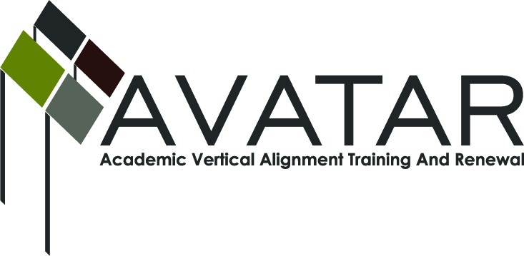
AVATAR Partnership Region: 2
Meeting/Session Documentation Form

Form should be completed after each meeting and given to the Regional AVATAR Coordinator/Facilitator
Meeting: | AVATAR Team Meeting
Meeting Purpose: | Monthly Meeting
Date: | February 9, 2015 | Start Time: | 3:00 p.m. | End Time: | 4:20 p.m.
Meeting Coordinator/ Facilitator: | Janet M. Cunningham | Location: |  | Northwest Center for Advanced Studies
Meeting Recorder: | Janet M. Cunningham | Meeting Timekeeper: |  | Connie Nowell

Time | Topic | Format | Discussion Leader | Desired Outcome
3:05 | Welcome | Discussion | Janet Cunningham
3:10 | Discussion Items | Discussion | Janet Cunningham | Continue follow up of semester one College Preparatory Assessment information and begin thinking about semester two assessment. Beginning discussion of ways IHEs can assist students in utilizing the career path/ endorsement attained in high school.
4:20 | Plans for Next Meeting |  | Janet Cunningham | Meeting date set.
Agenda Format Key: P = Presentation, F = Feedback, D = Decision-Making, W = Work Group, O = Other, with explanation

AVATAR Meeting Minutes

Action Item | Person Responsible | Due Date
Welcome: Dr. Cunningham welcomed all members and reviewed recent member events.  Discussion Items:  - College Preparatory Assessment, Semesters 1 and 2 – A request for data has been requested; none has been received. It was noted that there was no requirement that districts submit this information but that it would be to their benefit to do so in order that members could begin immediately to develop the second semester assessment and refine it if necessary. There followed an overall discussion of the course.  - Math Symposium Surveys – General discussion of the survey information provided to the group by Melissa Morin. Changes to better the presentations for next year were discussed, along with target audiences, and the need for current/timely information. A needs assessment of those who attended and/or were invited was discussed.  - Endorsements – How can AVATAR Assist? – Dr. Cunningham reported on her recent conference call and future purposes of the AVATAR group and how the group can aid IHEs in helping students continue with the career path/endorsement they attained in high school. She also discussed the upcoming Discover Your Direction: Exploring Endorsements conference scheduled for Friday, Feb. 13 for students in Grades 8, 9, 10.  Plans for Next Meeting: A meeting has been set for March 2. | Melissa Morin will issue a second request  for data and will also facilitate a meeting  between IHE and district partners.  AVATAR Group  AVATAR Group | Before March 2
Notes

Meeting Participant List

Name | Title | Organization/Institution
Dr. Janet M. Cunningham | Executive Director | E2E Partners (P-16 Council)
Paul Johnson | Math Instructor | Del Mar College
Elsa Brown | Owner | cMATHisEASY
Jose Guerra | Coordinator – Instructor Math | Texas A&M University-Kingsville
Andrea Johnson | Owner | cMATHisEASY
Dr. Paula Kenny-Wallace | Math Instructor | Texas A&M University-Corpus Christi
Melissa Morin | Consultant | ESC2

