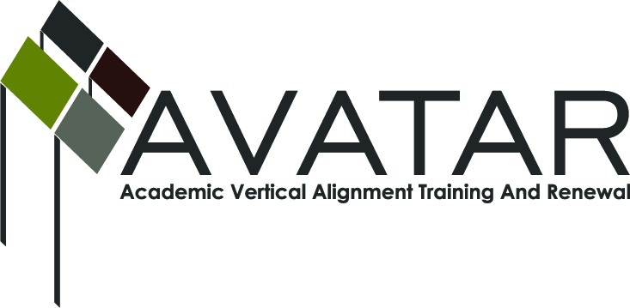
AVATAR Partnership Region: IX
Meeting/Session Documentation Form

Form should be completed after each meeting and given to the Regional AVATAR Coordinator/Facilitator
Meeting: | Math Seminar for Teachers: Building Your College Knowledge
Meeting Purpose: | Sustainability Plan Requirement
Date: | March 7, 2013 | Start Time: | 9:00 a.m. | End Time: | 3:00 p.m.
Meeting Coordinator/ Facilitator: | Christina Hoffmaster, Kathy Harvey | Location: |  | Vernon College, Century City Campus
Meeting Recorder: | Kathy Harvey | Meeting Timekeeper: |  | NA

Time | Topic | Format | Discussion Leader | Desired Outcome
9-9:30 | Introduction & Regression Lesson | P | Christina Hoffmaster  Vernon College | Using a graph activity to show teachers the impact when students don’t graduate h.s.
9:30-10:10 | Freshmen Math Placement at MSU | P | Dr. Mark Farris  MSU Math Dept. | Helping teachers to understand the basic math requirements for students entering college math courses: math calculator abilities.
10:15-10:30 | Intro to Career Coach/Resume Builder | P | Brandi Brannon  Vernon College | Demonstration of Career Coach: website allowing students to explore careers and their earning potential
10:30-10:45 | Math Placement at Vernon College | P | Dr. Karen Gragg  Vernon College | Explanation of the Texas Success Initiative Assessment to go in place August 2013 and developmental education impact for students.
10:50-11:10 | Overview of EOC Scoring | P | Ward Roberts  Math Coordinator, WFISD | Requirements for scoring on new math EOC exams and basic requirement levels for students in their math courses.
11:15-11:30 | Certificates of Vocational Programs | P | Dr. Gary D. Harkey  Vernon College | Courses and certifications available through Vernon College with math focus and the basic requirements for those courses.
12:30-2:15 | Tour of MSU School of Engineering and School of Health Sciences | P | Dr. Sheldon Wang  Catherine Rudy | Tour of facilities and math requirements and possibilities for students with these majors.
2:15-3:00 | Tour Vernon College: CNA, LVN, Nursing, Medical Tech, Emergency Tech Depts. | P | Dr. Gary Harkey | Tour of facilities and math requirements and possibilities for students with these majors.
Agenda Format Key: P = Presentation, F = Feedback, D = Decision-Making, W = Work Group, O = Other, with explanation

AVATAR Meeting Minutes

Action Item | Person Responsible | Due Date
Notes
15 teachers participated in the math seminar. Feedback was positive and teachers requested another opportunity in the fall, but would like to bring students as well.
Our goal will be to offer this again on an expanded basis.

Meeting Participant List

Name | Title | Organization/Institution
Kathy Harvey | Facilitator | AVATAR Grant Project
Christina Hoffmaster | Coordinator | Math Team
Dr. Karen Gragg | Math Dept. Chair  Vernon College | Math Team
Dr. Gary Don Harkey | Instructional Chair  Vernon College | Math /ELA Team
Ward Roberts | Math Coordinator  WFISD | Math Team
Dr. Mark Farris | Math Professor  Midwestern State University | Special Guest
Brandi Brannon | Director of Student Relations  Vernon College | Special Guest

