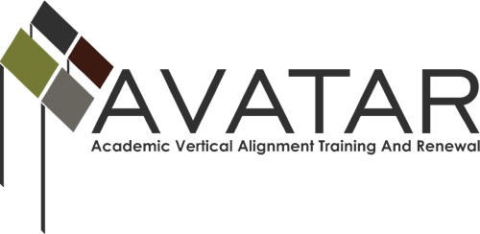

Action Plan – April 2015 to August 2016

ESC Region ______ or Other Organization ________

Date of Action Plan submitted to UNT ____________

Members of Partnership (Please list all)

Name (include yourself) | District/University/Workforce or P-16 Council | Title/Position | Email | Phone

Goals of partnership (These sample goals should be modified to focus on your specific areas of endorsement and vertical alignment.)
- Develop ISD, post-secondary, and workforce/ P-16 partnerships appropriate to local endorsement options
- Facilitate offering and documentation of College Preparatory Courses (CPCs) of the partnership
- Deepen vertical alignment of the ELA (this may be Math and/or Science) offerings of ISD and post-secondary partners

Objectives supporting your goals
1.
2.
3.

Plan of Work
# of Related Objective(s) Above | Activity | Planned Evidence of Implementation | Planned Evidence of Impact

Timeline, Responsibility, Resources, and Evaluation
Date | Activity | Who is Responsible | Resources Needed | Associated Evaluation

Budget plan
Anticipated activity (These are examples) | Personnel cost/Stipends | Travel | Materials/Supplies | Food | Consultant
April conference
5 VAT meetings
3 partnership steering meetings
4 CPC consultations
TOTAL

