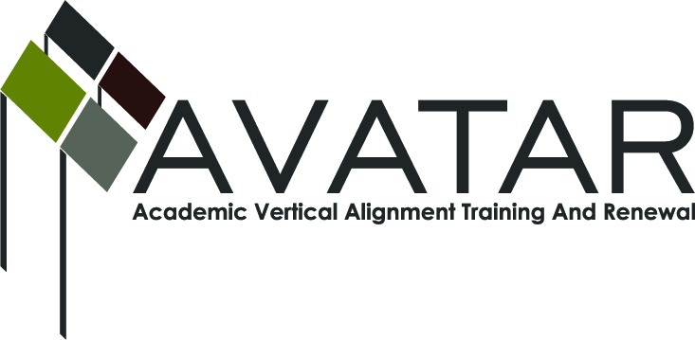
AVATAR Partnership Region: 2
Meeting/Session Documentation Form

Form should be completed after each meeting and given to the Regional AVATAR Coordinator/Facilitator
Meeting: | AVATAR Team Meeting
Meeting Purpose: | Information Meeting
Date: | April 26, 2016 | Start Time: | 3:00 p.m. | End Time: | 4:50 p.m.
Meeting Coordinator/ Facilitator: | Janet M. Cunningham | Location: |  | Northwest Center for Advanced Studies
Meeting Recorder: | Janet M. Cunningham | Meeting Timekeeper: |  | Connie Nowell

Time | Topic | Format | Discussion Leader | Desired Outcome
3:00 | Welcome | Discussion | Janet Cunningham
3:05 | Finalize Spring 2016 CPC Math Exam | Discussion | Bethany Goralczyk | Final revisions to assessment
3:22 | Analyze CPC Fall Assessment | Discussion | Janet Cunningham
4:16 | Discuss College Preparatory Course | Discussion | Janet Cunningham
4:40 | Plans for Next Meeting | Discussion | Janet Cunningham | Set next meeting date

AVATAR Meeting Minutes

Action Item | Person Responsible | Due Date
Welcome: Dr. Cunningham welcomed members.  Finalize Spring 2016 CPC Math Exam: Team members discussed draft of the math assessment for spring 2016. Minor changes were made. The addition of a cover sheet with instructions will be added. The final will be prepared and distributed to districts next week.  Analyze CPC Fall Assessment: Members reviewed data from fall 2015 assessment.  May Math Meeting: Mr. Mendoza discussed expectations for May meeting of district math teachers and members of IHEs. The purpose of the meeting is to get teachers up to speed and to review expectations, objectives, resources, curriculum, etc.  Discuss College Preparatory Course (CPC):  - Partner List. Melissa Morin informed members that 19 districts had returned their MOU. She has also heard from several others who wish to participate.  - Parent Letter/FAQ. Discussion centered on districts’ reasons for not enrolling students in the course.  - Website. Discussion of what should be included on the website – as much information as possible, to include syllabus for math and ELA, FAQs, list of partners, etc.  - Tentative Timeline. A timeline of events for the council was reviewed.  Stipends. Stipends will be delivered at the June meeting.  Plans for Next Meeting: A meeting has been set for Wednesday, June 8, at a time and place to be determined. | Bethany Goralczyk  Steven Mendoza  Melissa Morin | April 29
Notes

Meeting Participant List

Name | Title | Organization/Institution
Dr. Janet M. Cunningham | Executive Director | E2E Partners (P-16 Council)
Bethany Goralczyk | Assistant Math Instructor | Del Mar College
Melissa Morin | Human Resources Administrator | ESC-2
Steven Mendoza | Secondary Mathematics Specialist | ESC-2
Shelly Key | Executive Director of Admissions | TAMUK
Michael Holland | Teacher | Banquete ISD
Tammy Donaldson | Reading/ELA Instructor | Del Mar College
Melana Silva | Curriculum Director | Calallen ISD

