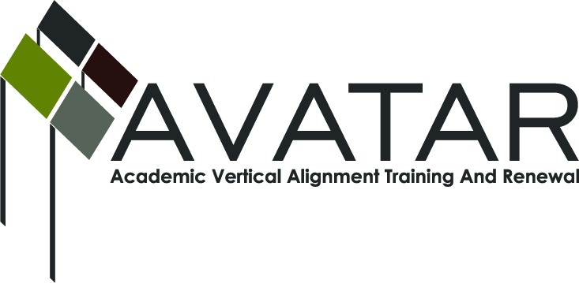
AVATAR Partnership Region: 2
Meeting/Session Documentation Form

Form should be completed after each meeting and given to the Regional AVATAR Coordinator/Facilitator
Meeting: | AVATAR Team Meeting
Meeting Purpose: | Focus of Work
Date: | September 17, 2013 | Start Time: | 3:00 p.m. | End Time: | 4:30 p.m.
Meeting Coordinator/ Facilitator: | Janet M. Cunningham | Location: |  | STAR Annex
Meeting Recorder: | Janet M. Cunningham | Meeting Timekeeper: |  | Connie Nowell

Time | Topic | Format | Discussion Leader | Desired Outcome
3:00 p.m. | Welcome | Discussion | Melana Silva | Introduction of new members; discussion of article concerning changing approach to teaching math
3:15 p.m. | Discussion Items | Discussion | Janet Cunningham
4:15 p.m. | Mathematics Symposium | Discussion | Janet Cunningham
4:20 p.m. | Next Meeting | Discussion | Janet Cunningham | Set date
Agenda Format Key: P = Presentation, F = Feedback, D = Decision-Making, W = Work Group, O = Other, with explanation
AVATAR Meeting Minutes

Action Item | Person Responsible | Due Date
Discussion Items:  - Campus, Region, State Data  - Legislative Update  - Curriculum Update  - TSI Assessment  General discussion of all items among group members. The discussion focused on legislative changes and how those changes would affect teaching math and how best to prepare students for those changes. There was also a general discussion on how the legislative changes will affect high school graduation plans. College ready math courses were also discussed. Professor George Tintera, Texas A&M University-Corpus Christi, shared his syllabi for his math classes. The group shared the difficulties that curriculum specialists were encountering in trying to second guess the legislature since no clear guidelines have been issued and what this will mean in trying to set courses for upcoming semesters. The discussion then centered on the TSI and how that will affect those students who want to take dual credit courses. Dr. Cunningham then went over some demographic information for the region. She will send out a spreadsheet for the members to complete and bring to the next meeting. Members will also review one AVATAR module and report to members at the next meeting. | All members should complete the demographic spreadsheet which Dr. Cunningham will be forwarding to them | October 28, 2013
Mathematics Symposium - February 12 at ESC from 9:00 a.m. to 3:00 p.m. | Janet Cunningham has asked all members to be thinking about possible sessions for the symposium | October 28
Next meeting – Monday, October 28, at 3:00 p.m., STAR Annex, 4201 Calallen Dr., Room D-9
Notes

Meeting Participant List

Name | Title | Organization/Institution
Dr. Melana Silva | Curriculum Specialist | Calallen ISD
L. Gay Palmero | Curriculum Specialist | Odem-Edroy ISD
Carlos Guerrero | Instructional Coach | Robstown ISD
Dr. Janet M. Cunningham | Executive Director | Coastal Bend Partners for College and Career Readiness (P-16 Council)
Lisa Hernandez | Math Teacher | Odem-Edroy ISD
Toni Norrell | Math Specialist | ESC-2
Paul Johnson | Associate Professor | DelMar College
Yolanda Reyna | Director for Federal/Special Programs | Robstown ISD
George Tintera | Professor | Texas A&M University-CC
Shere Salinas | Secondary Math Specialist | Corpus Christi ISD
Melissa Morin | Research and Planning | ESC-2

