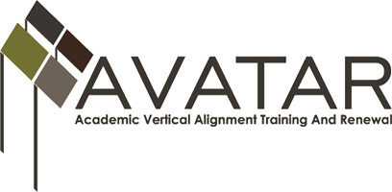
Partnership Meeting – Region 8
Monday, April 11, 2016
Agenda
    - Introductions
    - AVATAR Rationale and Goals
    - Partners and Roles
    - Action Plan for Region 8
    - Partner Responsibilities
BREAK
    - Data
    - HB 5 and College Preparatory Course Requirements
    - TSI Outcomes of Local School Districts
    - TSI and DE Placement at TC
    - MOUs and Syllabi for College Preparatory Courses
    - Curriculum Discussion
    - Schedule Next Meeting and Professional Development Session

www.untavatar.org

