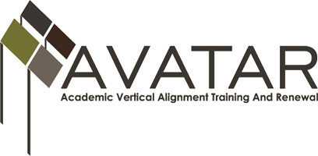

Partnership Meeting – Region 8
WEDNESDAY, MAY 25, 2016 9-11 a.m.
Agenda

    - Professional Development Date – June 2, 2-4 p.m.
    - Information to Include in Presentation
- Background for HB5 College Preparatory Courses
- AVATAR
- Data related to college ready and college enrollment
- Benefit to Students
- TC’s role
- A&M’s role
- ISD’s roles
- Process taken by DeKalb ISD to implement courses
- Viewpoints: Administration, Counselor, Teachers
- Scheduling, Curriculum, Success, Problems, Etc...
- Resources for other ISDs
    - Order of Presentation/Power Point
    - Documents/Handouts
    - Other

www.untavatar.org

