Boyle's Gas Law: Marshmallow Under Pressure

By Pam Walker | Elaine Wood John Wiley & Sons, Inc.
Boyle's Law states that when temperature is held constant, the volume—the amount of space occupied by matter—of a gas is inversely proportional to its pressure, the force per unit area. This simply means that if the pressure increases and temperature remains the same, the volume decreases. The opposite is also true (if the pressure decreases and the temperature remains the same, the volume increases). This activity will demonstrate Boyle's Law using a marshmallow and a syringe.

Materials
Large plastic syringe (without a needle); Large marshmallow; Felt-tip pen

Activity
- Draw a face on one side of the marshmallow and place it in the plastic syringe so the face can be seen from the side.
- Place your thumb over the end of the syringe where the needle is usually located. Holding your thumb in place, push in the plunger. Observe what happens to the marshmallow as you do so.
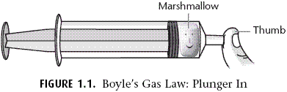
- With your thumb still in place, pull the plunger out and observe what happens.
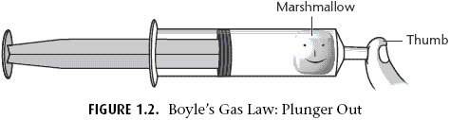

Follow-Up Questions
- Marshmallows have bubbles of air trapped inside. What happened to the marshmallow when you pushed in the plunger? What happened when the plunger was pulled out?
- Relate this demonstration to the definition of Boyle's Law. How did this demonstration verify the accuracy of that law?

Answers
- When you pushed in the plunger, the air pressure increased, pushing the bubbles out of the marshmallow and decreasing its size. When the plunger was pulled out, the pressure decreased so the marshmallow expanded in size.
- Boyle's law says that when temperature is constant, the pressure and volume are inversely related. This means that when pressure is low, volume is high, and vice versa. This is what you saw happen in the activity.

