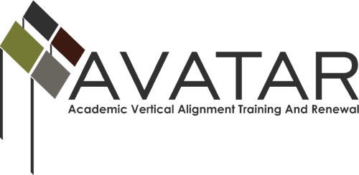

Action and Sustainability Plan with Measurable Outcomes – August 2013 to August 2014

Region: 11

Date | Vertical Alignment Actions | Resources Required and Persons Responsible | Implementation Steps | Outcomes/Evidence of Impact
October 25, 2013  December 2,2013  December 11, 2013 | Convene Vertical Alignment Partners | Kathy Wright-Chapman, ESC Region 11 Coordinator/Facilitator | Meet with key district leaders (Burleson ISD, Cleburne ISD, Godley ISD and Joshua ISD) to determine 2014 AVATAR focus | Set Spring 2014 team meetings and identified writing in the CTE classroom as the focus for the project  - January 23, 2014 – session location Burleson ISD  - February 10, 2014 – session location in Joshua ISD  - March (date to be determined) – session location in Godley ISD
January 23, 2014 | Convene Course Vertical Alignment Team Members | Kathy Wright-Chapman, ESC Region 11 Coordinator/Facilitator | Team members will discuss the following topics and provide classroom connections  - AVATAR Project Goals and Outcomes  - Examine state, regional, and district data (STAAR, EOC, SAT, ACT, and Texas Success Initiative  - HB5 update  - Texas Success Initiative postsecondary assessment tool update  - College and Career Readiness Standards | Vertical team will create connections to the classroom and collaboratively determine the design of the AVATAR writing product. Product will be aligned to the ELA and CTE TEKS and CCRS.
February 10, 2014 | Convene Course Vertical Alignment Team Members | Kathy Wright-Chapman, ESC Region 11 Coordinator/Facilitator | Team members will discuss the following topics and provide classroom connections.  - TEKS Writing in the Secondary Classroom (ELA and CTE Course of Study TEKS connections, strategies, evaluation, and resources) Postsecondary Connections to Core Curriculum and higher education writing expectations  - AVATAR project product development | Vertical team will create connections to the classroom and begin identifying writing non-negotiable outcomes, instructional strategies and evaluation.
March 2014 | Convene Course Vertical Alignment Team Members | Kathy Wright-Chapman, ESC Region 11 Coordinator/Facilitator | AVATAR project team members will create a collaborative writing product designed for CTE teacher. The document could also be used across the disciplines. | AVATAR writing product will be finalized and disseminated to Joshua ISD, Godley ISD, and Burleson ISD CTE and ELA staff.
June 6, 2014 | Co.  Attend AVATAR statewide meeting | Kathy Wright-Chapman, ESC Region 11 Coordinator/Facilitator | Share AVATAR project success | AVATAR project product posted on AVATAR statewide website. Identify AVATAR Project next steps for the 2014-2015 school year.
August 15, 2014 | Submit 2013-214 Outcomes and Activity Report | Kathy Wright-Chapman, ESC Region 11 Coordinator/Facilitator | Submit report as required | AVATAR project document shared with district stakeholders and identify next steps for the vertical team.
August 22, 2014 | Provide Accounting of Fund Expenditures | Kathy Wright-Chapman, ESC Region 11 Coordinator/Facilitator | Submit report as required | Funding expended

