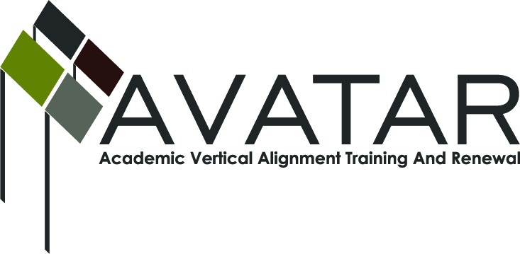
AVATAR Partnership Region: _____15_____________
Meeting/Session Documentation Form

Form should be completed after each meeting and given to the Regional AVATAR Coordinator/Facilitator
Meeting: | Curriculum vertical alignment
Meeting Purpose: | Plan project
Date: | 12/11/13 | Start Time: | 9:00 | End Time: | 11:00 a.m.
Meeting Coordinator/ Facilitator: | Karan Duwe | Location: |  | Region 15 ESC
Meeting Recorder: | Karan Duwe

Time | Topic | Format | Discussion Leader | Desired Outcome
9:00 | Introduce Avatar, | F | Karan Duwe | Awareness of Avatar funding and resources
9:15 | Discuss HB 5 and impact on alignment | F | Karan Duwe | Discussion of needs
10:00 | Discuss ways to create the course | F | Karan Duwe | Create a plan
10:30 | Determine plan | F | Karan Duwe | Create plan, determine responsibilities
Agenda Format Key: P = Presentation, F = Feedback, D = Decision-Making, W = Work Group, O = Other, with explanation

AVATAR Meeting Minutes

Action Item | Person Responsible | Due Date
Gather syllabi of all area colleges/universities developmental courses | Entire group | February 2014
Plan meeting to work on course with district representatives, Higher Ed reps. | Karan Duwe, Michael Bohensky, Caroline Tolliver, Lorrie Payne | February 2014
Notes
Meeting Participant List

Name | Title | Organization/Institution
Karan Duwe |  | ESC 15
Michael Bohensky | Assistant Superintendent | San Saba ISD
Lorrie Payne | Curriculum Director | Coleman ISD
Liesa Land | Assistant Superintendent | Brownwood ISD
Caroline Tolliver | Curriculum Director | Ballinger ISD

