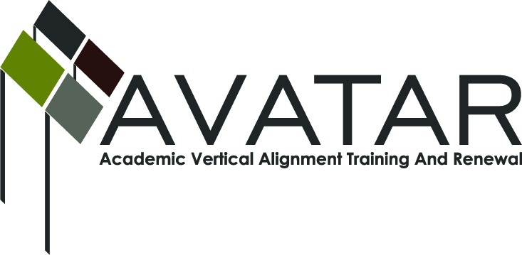
AVATAR Partnership Region: 2
Meeting/Session Documentation Form

Form should be completed after each meeting and given to the Regional AVATAR Coordinator/Facilitator
Meeting: | AVATAR Team Meeting
Meeting Purpose: | Focus of Work; Symposium Review
Date: | March 3, 2014 | Start Time: | 3:10 p.m. | End Time: | 4:40 p.m.
Meeting Coordinator/ Facilitator: | Janet M. Cunningham | Location: |  | STAR Annex
Meeting Recorder: | Janet M. Cunningham | Meeting Timekeeper: |  | Connie Nowell

Time | Topic | Format | Discussion Leader | Desired Outcome
3:15 p.m. | Welcome | Discussion | Janet Cunningham
3:18 p.m. | Discussion Items | Discussion | Janet Cunningham | Plan for next math symposium
4:01 p.m. | College Preparatory Course | Discussion | Janet Cunningham
4:44 p.m. | Next Meeting | Discussion | Janet Cunningham | Set date
Agenda Format Key: P = Presentation, F = Feedback, D = Decision-Making, W = Work Group, O = Other, with explanation
AVATAR Meeting Minutes

Action Item | Person Responsible | Due Date
Discussion Items:  - Mathematics Symposium  Discussion of what worked, what changes are needed, how to ensure continued attendance, and how to increase IHE participation.  What worked: The early morning student panel should be repeated as it was a great success. Presentations were substantial and contained information which teachers did not know and which can be passed on to students.  What changes are needed: An exit survey before participants leave would be helpful, as well as a follow up newsletter. It might be beneficial to partner with Me By The Sea for a follow up.  Ensure continued attendance: HB5 should be relevant for at least the next two years. Set the date for the next symposium as early as possible and possibly have the ESC provide more marketing.  Increase IHE participation: Check feasibility of having two sessions, one for secondary educators and one for post-secondary educators, with the two sessions overlapping for combined interests. Notify HE as early as possible so that the date can be added to calendars.  - College Readiness Course  Continued discussion of how this course will work, which students it will serve, and how to present it in a way that will serve all applicable students. | Janet Cunningham  Toni Norrell to check availability of ESC for possible October 2014 date | March 31, 2014
Next meeting – Monday, March 31, at 4:00-5:30 p.m., STAR Annex, 4201 Calallen Dr. | Dr. Janet Cunningham
Notes

Meeting Participant List

Name | Title | Organization/Institution
George Tintera | Associate Professor | Texas A&M University-CC
Dr. Melana Silva | Curriculum Coordinator | Calallen ISD
Dr. Janet M. Cunningham | Executive Director | E2E Partners (P-16 Council)
Carlos Guerrero | Instructional Coach | Robstown ISD
Paula Kenney-Wallace | Division Chair | Coastal Bend College
Toni Norrell | Math Specialist | ESC-2

