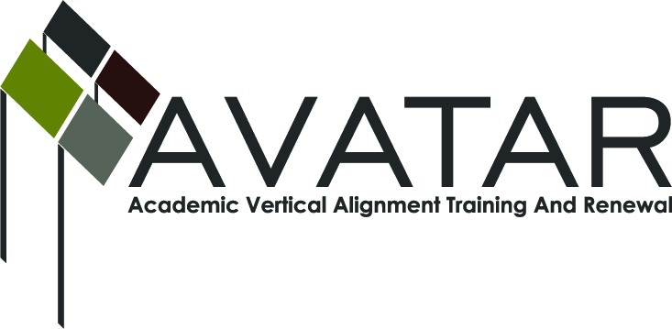
AVATAR Partnership Region: 2
Meeting/Session Documentation Form

Form should be completed after each meeting and given to the Regional AVATAR Coordinator/Facilitator
Meeting: | AVATAR Team Meeting
Meeting Purpose: | Focus of Work
Date: | March 31, 2014 | Start Time: | 4:00 p.m. | End Time: | 5:25 p.m.
Meeting Coordinator/ Facilitator: | Janet M. Cunningham | Location: |  | STAR Annex
Meeting Recorder: | Janet M. Cunningham | Meeting Timekeeper: |  | Connie Nowell

Time | Topic | Format | Discussion Leader | Desired Outcome
4:05 p.m. | Welcome | Discussion | Janet Cunningham
4:08 p.m. | Discussion Items | Discussion | Janet Cunningham | Plan for next math symposium
5:23 p.m. | Next Meeting | Discussion | Janet Cunningham | Set date
Agenda Format Key: P = Presentation, F = Feedback, D = Decision-Making, W = Work Group, O = Other, with explanation
AVATAR Meeting Minutes

Action Item | Person Responsible | Due Date
Discussion Items:
- Mathematics Symposium
Members reviewed the evaluations from the symposium; attendance and scores were up and overall comments were favorable. There was discussion of what changes might be needed.
- College Preparatory Course
Lengthy discussion of how this course will be implemented. Dr. Cunningham shared Texas A&M-Kingsville’s proposal for the course. Discussion included the charge for the course and how that would impact the number of students who would take the course, as well as the fact that there would be no credit for the course; how districts would provide qualified teachers to present the course; those students who should take the course; whether the course should be a full year of preparatory work or if the course could be divided into two semesters – one for preparatory and the second for dual credit, etc. There was discussion regarding Avatar developing the course and what would be needed to do so: a clear syllabus, some measure of student activity, some measure of performance, etc. Coastal Bend College offered that they were offering training courses for school districts. Some form of training would need to be offered to all high school instructors who would be teaching the course. A planning date needs to be set, possibly in conjunction with Me By The Sea.
- Counselor (or anyone?) Conference
Discussion of what such a conference should include – what’s coming regarding HB5 would be most informative. ESC is holding a conference in November or December. More discussion is needed.
Next meeting – Wednesday, April 30, at 4:00 p.m., STAR Annex, 4201 Calallen Dr. | Dr. Janet Cunningham
Notes

Meeting Participant List

Name | Title | Organization/Institution
George Tintera | Associate Professor | Texas A&M University-CC
Dr. Melana Silva | Curriculum Coordinator | Calallen ISD
Dr. Janet M. Cunningham | Executive Director | E2E Partners (P-16 Council)
Carlos Guerrero | Instructional Coach | Robstown ISD
Paula Kenney-Wallace | Division Chair | Coastal Bend College
Toni Norrell | Math Specialist | ESC-2
Melissa Morin | Research & Planning | ESC-2
Sandra K. Rippstein | Math Teacher | Calallen ISD
Lisa Hernandez | Math Teacher | Odem-Edroy ISD
Cindy Funke | Math Teacher | Odem-Edroy ISD
Paul Johnson | Math Instructor | Del Mar College
Phillip Vucins | Math Instructor | Del Mar College

