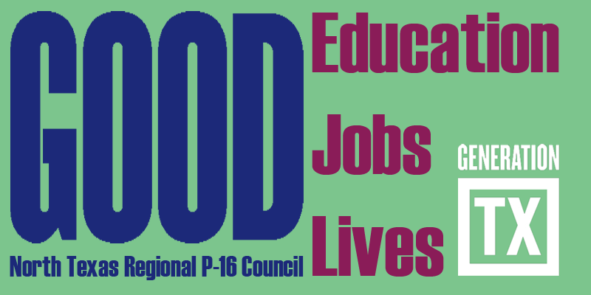
http://www.ntp16.notlb.com
North Texas Regional P-16 Executive Committee Meeting Minutes
April 10, 2012 9:30am- 12:30pm
Dallas County Community College District Office
1601 S. Lamar St. Dallas, TX. 75215
Room 333
Don Perry Host

Present:

V. Barbara Bush, Francine Holland, Ray de los Santos, Cynthia Fisher Miller, Rick Garcia, Mary Harris, Jean Keller, Anna Garza for Barbara Lerner, Don Perry

- Welcome
Greetings and welcome to Dallas County Community College District. Jean Keller welcomed the Executive Committee. The Committee members shared thanks with Don Perry and Dallas County Community College District for hosting the NTRP-16 Executive Committee and their warm hospitality.

- January 10, 2012 NTRP-16 Executive Committee Meeting Minutes
The committee reviewed the approved minutes. Several typographic errors were corrected and minutes will be posted on the Council's website.

- Approval of March 6, 2012 NTRP-16 Council Meeting Minutes
Don Perry moved for approval and Cynthia Fisher Miller seconded approval of the March 6, 2012 Council meeting minutes with several editorial changes. Motion passed. Minutes will be distributed at the May 8, 2012 Council meeting and posted on Council's website.

D. Updates from Executive Committee Members
Vertical Alignment Training Project (AVATAR)
Mary Harris summarized the pilot testing of AVATAR and shared the AVATAR outcomes and goals:

I. Create and extend sustainable vertical alignment secondary and post-secondary networks.
a. Expand awareness of vertical alignment initiatives within the region and beyond
b. Identify and implement strategies to close secondary and post- secondary content and process curriculum gaps
1. Understand state standards and assessments that define secondary and post- secondary curriculum alignment
2. Become knowledgeable about policies and procedures of secondary and post- secondary curriculum design and delivery, including an examination of course profiles.
c. Identify processes to annually assess local progress toward closing the student achievement gaps between secondary and post-secondary
d. Disseminate within peer groups, administrative leadership teams, P-16 councils, and other relevant groups information and findings from the secondary and post- secondary vertical alignment network sessions to maximize impact.

Francine Holland reported Phase III of AVATAR involves bringing together secondary, postsecondary, P-16 Council, and Education Service Center participants from 12 regions across the state to engage in a “Training of Trainers” session. The regions that have agreed to participate are ESC’s 2, 6, 7, 9, 10, 11, 12, 13, 14, 15, 16, and 20. The goal is to provide a framework and resources for the teams to engage in vertical curriculum alignment in their region. The training modules were developed during pilot testing to encourage participants to a number of issues that impact curriculum alignment and student success. August 13, 2012 is the training date. Please plan to participate.

Feria Para Aprender, 2012
Ray de los Santos informed the committee that no date has been set for Feria Para Aprender, 2012.

State of the Region Conference
Don Perry advised that there is a need for full council participation in designing the State of the Region Address conference. Rick Garcia and Don Perry expressed concern about having enough time to prepare for the State of the Region conference for October 2012 and they proposed it be held in October 2013. Francine suggested looking at the Creating a New Vision for Public Education in Texas report (posted on Council's website). Action Item: The committee is asked to review the vision document. Time on the May 8 Council agenda will for the State of the Region conference planning.

GenTX Day
Anna Garza informed the group about GenTx College T-shirt Day on May 4, 2012 and encouraged all to promote it. Council members are encouraged to wear T-shirts honoring their alma mater. TWU will host a GenTx Day.

Second Annual College and Career Readiness Conference for Counselors
Anna Garza reported plans are being made to host the event in the fall and in the Fort Worth area.

Math Vertical Alignment Training
April 21, 2012 at TWU, local colleges and universities, and the North Texas Regional P-16 Council will host Mathematics educators for Math vertical alignment training. Please see Council’s website for further information.

Council Financial Update
Jean Keller informed the committee that the Council’s total funds were $5447.09. The sustainability of the Council was discussed.
Action Item: Council will cover the cost of registration fees for three Council members to attend the Statewide P-16 Institute.

Statewide P-16 Institute
Jean Keller sought volunteers from the Committee to attend the P-16 Institute in Austin on June 12, 2012.
Action Item: Jean will ask Donna Solley to attend. Barbara Bush thought she would be able to participate; yet, is unable. Would a Council member like to participate?

E. NTRP-16 Council Annual Report/Update/Gap Analysis?
Jean Keller referred the Committee to view the All Kid’s Alliance 2011 Update. She noted that the format to present the data was professional and useful. She shared corporate sponsorship made this possible. A comprehensive Gap Analysis would require further funding.
Action Item: V. Barbara Bush and the Research, Assessment, and Accountability will discuss their role related to the Gap Analysis.

- Selection of New Executive Committee Member
Brenda Kihl resigned due to work duties. Brenda was thanked for her excellent service. Action Item: The committee nominated Deborah Endres to serve on the Executive Committee. Deborah accepted the position. Thanks and welcome Debbie.

- Create and Approve May 8, 2012 NTRP-16 Council Meeting Agenda
The Committee decided to revise the agenda to address the State of the Region conference.
Action Item: The agenda will be approved via email and emailed to all Council members by April 17th

- Approve 2012-2013 Council Meeting Dates and Set Locations

September 18, 2012 - TBD
December 4, 2012 - Education Service Center Region XI, Fort Worth
February 19, 2013 - Dallas County Community College District, a campus, Dallas
May 7, 2013 – Fort Worth Chamber of Commerce, Ft. Worth

Future Council Meetings

May 8, 2012 9:30am-12:30pm Tarrant County College – Trinity River Campus
Fort Worth, TX - Action C Room

Future Executive Committee Meetings
June 5, 2012 9:30am – 12:30pm Fort Worth Chamber of Commerce
Hosted by: Cynthia Fisher Miller

August 7, 2012 9:30am – 12:30pm University of North Texas-Mean Green Village
Hosted by: V.B. Bush

