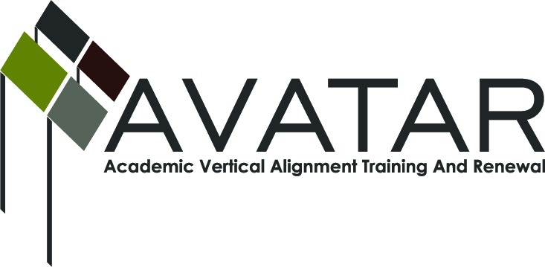
AVATAR Partnership Region: ______1________
Meeting/Session Documentation Form

Form should be completed after each meeting and given to the Regional AVATAR Coordinator/Facilitator
Meeting: | Region 1 Science Vertical Alignment Team Meeting
Meeting Purpose:
Date: | January 9, 2013 | Start Time: |  | End Time:
Meeting Coordinator/ Facilitator: | Laura Saenz | Location:
Meeting Recorder: | Laura Saenz | Meeting Timekeeper: |  | Volunteer

Time | Topic | Format | Discussion Leader | Desired Outcome
 | Brief Introductions | O  (discussion) | Laura Saenz | Introductions between team members.
 | Shared definitions of alignment: vertical & horizontal | P & F | Laura Saenz | Explore personal definitions and develop shared understanding
 | Identify vision for our work | O  (discussion) | Laura Saenz | Develop an aspirational definition of what team would like to achieve in the mid-term and long-term future to serve as a clear guide for choosing course of action.
 | Action planning | D | Laura Saenz | Identify short-term and long-term goals.
 | Standards & Assessments | P | Laura Saenz | Create shared understandings among team members of the STAAR, TEKS, CCRS, and 2-year and 4-year course content.

AVATAR Meeting Minutes

Action Item | Person Responsible | Due Date
Notes

Meeting Participant List

Name | Title | Organization/Institution

