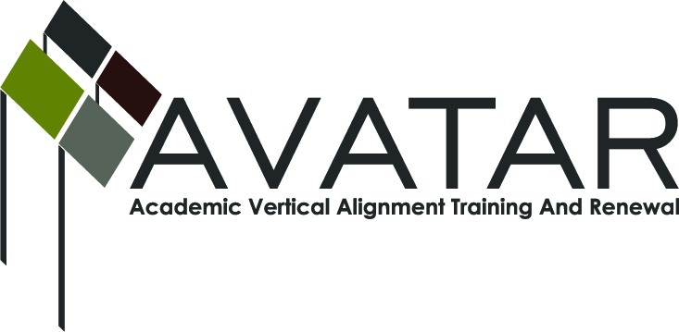
AVATAR Partnership Region: ______1________
Meeting/Session Documentation Form

Form should be completed after each meeting and given to the Regional AVATAR Coordinator/Facilitator
Meeting: | Region 1 Science Vertical Alignment Team Meeting
Meeting Purpose:
Date: | November 30, 2012 | Start Time: | 4:00 | End Time: | 6:00 pm
Meeting Coordinator/ Facilitator: | Laura Saenz | Location:
Meeting Recorder: | Laura Saenz | Meeting Timekeeper: |  | Volunteer

Time | Topic | Format | Discussion Leader | Desired Outcome
4:00 – 4:30 pm | Introductions & Opening Activities | P & O  (discussion) | Laura Saenz | Introduce team members, summarize past meetings, and explain AVATAR.
4:30 – 4:40 pm | Data examined and/or collected | P & D | Laura Saenz | Present the data and make decisions regarding the use of the data.
4:40 – 5:40 pm | Examine chemistry courses across secondary and postsecondary | W | Laura Saenz | Examine course descriptions, standards, and related assessments
5:40 – 5:50 | Other | D | Laura Saenz | Discuss expansion to other faculty and dissemination of work

AVATAR Meeting Minutes

Action Item | Person Responsible | Due Date
Notes
I. Welcome and opening activities [4:00 to 4:30]
-Introductions
-Volunteer to take notes

What is AVATAR?
- AVATAR is a statewide network of regional partnerships, focused on secondary and postsecondary vertical alignment, to support students’ college and career readiness and success.
-AVATAR is a Texas Higher Education Coordinating Board (THECB) funded project which is implemented by the North Texas Regional P-16 Council and the University of North Texas.
-Goals:
- Expand awareness of and create regional vertical alignment initiatives to prepare and support students who are ready and successful in colleges and careers
- Identify and implement strategies to close regional academic course and expectation gaps
- Identify processes to assess and celebrate regional progress in preparing college and career readied students
- Share best practices statewide
-See “Houston Pathways Initiative” for more information

Previous Meetings: October 26th and November 9th
-Three themes: (a) secondary to post-secondary curriculum alignment including examination of courses and student level data, (b) in-service teacher knowledge and development, and (c) the soft skills associated with college readiness and success.

-Discuss article “Have Things Changed in 25 Years?”
-Discuss article “Study of the Intersection of Dual Credit Course Policies and End of Course Requirements”

II. Data to be examined and/or collected [4:30 to 4:40]
-THECB Pathways Data: MOU with PSJA-data being corrected and/or entered
-Review sample Pathways report
-Data template for secondary to post-secondary coursework
-UTPA can run PSJA reports with student last name, first name, and date of birth. School district can include a column indicating whether student took regular, Pre-AP or AP science coursework.
- Should we include all science courses in our report as was done with Pathways?
- What are the questions we want to ask? This will dictate the variables we include in our data.

III. Examine chemistry courses across secondary and post-secondary institutions [4:40 to 5:40]
-Majors requiring chemistry
-UTPA Chemistry course catalog description
-Academic Course Guide Manual chemistry course description
-UTPA course syllabi
-STC course syllabi
-PSJA: AP, Pre-AP and Regular PSJA Course Syllabi
-STAAR Chemistry Blueprint
-STAAR Release Test
-Chemistry TEKS
-College and Career Readiness Standards: specify the knowledge and skills necessary to succeed in entry-level community college and university courses (see page a35 for Chemistry standards).
-Reference syllabi from UNT
-AVATAR Postsecondary Course Profile Alignment Template

III. Other [5:40 to 5:50]
-Survey UTPA & STC faculty, Secondary faculty and students
-When do we include others?
-Dissemination of our work

IV. Future Meeting Dates and Agendas [5:50 to 6:00]
-December (?? ? only three weeks), January, February, March, April and May date

Meeting Participant List

Name | Title | Organization/Institution
Daniel Plas |  | UTPA
Laura Saenz |  | UTPA
Tim Spears |  | UTPA
John Villarreal |  | UTPA
Ludivina Avila |  | STC
Mahmoud Gassem |  | STC
Israel Nicanor |  | PSJA
David Gregorio Garza |  | PSJA
Luis Suarez |  | PSJA

