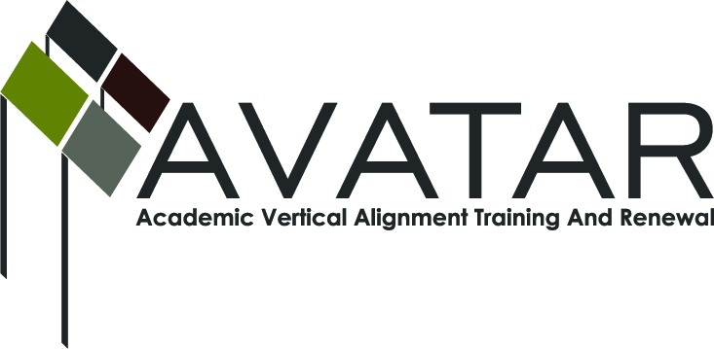
AVATAR Partnership Region: _____15_____________
Meeting/Session Documentation Form

Form should be completed after each meeting and given to the Regional AVATAR Coordinator/Facilitator
Meeting:
Meeting Purpose: | Determine agenda for round table discussion.
Date: | 1/17/13 | Start Time: | 3:00 | End Time: | 4:30
Meeting Coordinator/ Facilitator: | Karan Duwe | Location: |  | Region 15 ESC
Meeting Recorder: | Karan Duwe | Meeting Timekeeper: |  | Laurence Musgrove

Time | Topic | Format | Discussion Leader | Desired Outcome
3:00 | Essays and rubrics | F | Laurence Musgrove | Consensus on use for RT discussion
3:30 | Format for round table discussion | F | Laurence Musgrove | Consensus on agenda for RT discussion
3:45 | Date and time | D | Claudia Becerra  Karan Duwe | Set date and times and refreshments
4:00 | Assign duties for RT night | D | Karan Duwe | Group will lead discussions and present info on AVATAR project.
Agenda Format Key: P = Presentation, F = Feedback, D = Decision-Making, W = Work Group, O = Other, with explanation

AVATAR Meeting Minutes

Action Item | Person Responsible | Due Date
Copies of Rubrics and essays for discussion | Karan Duwe | 2/7/13
Order snacks for meeting | Karan Duwe | 2/7/13
Invite teachers to RT discussion | Claudia Becerra, Jean Hase, Connie Lindsey | 2/7/13
Notes
Table tents for name tags will be available for all participants
Agenda:
- Background to project Lorenzo, Karan
- Purpose, Laurence
- Task leader, rank essays
  - Discuss essays(examples of early college writing)
  - Rank
  - Rubrics
  - Conversation about expectations
- Table leaders will report out to group
- Course Packet purpose (copies of course packet sample)(copy of those in attendance)
  - Volunteers to work on course packet.
  - Dates set (2/21, 3/7, 3/21, 4/4,) Time TBD 4 meeting commitment 4/18 celebration date (catered dinner here) Kenny Blanyck
Visuals on PowerPoint to help set the tone and objectives for the evening. Laurence Musgrove volunteered to create those.
Table discussions:
Rank the essays. They are all Narratives. Reflections on the good, bad and ugly.
Discuss the rubrics. Useful, confusing? Does it meet college readiness standards? Does it relate EOCs?
Discuss what grade would be assigned.
Expectations of types of writing. Is the focus of EOC writing the same as college expectations? Writing types , narratives, essays, length.
Stipend details: ssn? What all do we need?
Follow up in spring of next year to see if it needs to be revisited. If state changes occur, what changes need to be made?
Resource sharing.
AVATAR advisory team? Advisor groups for college ready kids. Concho Valley Teachers of English has website that teachers can share resources Life beyond the project.
Snacks, Cheese, crackers, fruit, veggie trays, chocolate, cookies. Tea, coffee, water

Prepare Algebra teachers/Mathematics? When do we begin this process?

Meeting Participant List

Name | Title | Organization/Institution
Karan Duwe |  | ESC 15
Jean Hase | Teacher | SAISD
Nancy Treadwell | Instructor | Howard College
Angie Frage | Instructor | ASU
Laurence Musgrove | Teacher | ASU
Claudia Becerra | Teacher | SAISD
Gwen Parsons | Teacher | Howard College
Terrie Phillips | Director of AP, GT | SAISD
Lee Ann Byrd | Dean | Howard College

