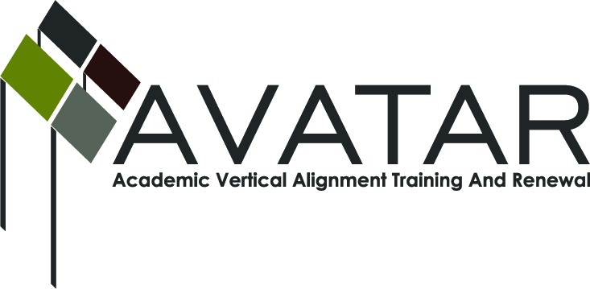
AVATAR Partnership Region: _____15_____________
Meeting/Session Documentation Form

Form should be completed after each meeting and given to the Regional AVATAR Coordinator/Facilitator
Meeting: | English AVATAR celebration
Meeting Purpose: | Celebrate accomplishments
Date: | 4/18/13 | Start Time: | 4:30 | End Time: | 6:30
Meeting Coordinator/ Facilitator: | Karan Duwe | Location: |  | Region 15 ESC
Meeting Recorder: | Laurence Musgrove | Meeting Timekeeper: |  | Connie Lindsey

Time | Topic | Format | Discussion Leader | Desired Outcome
4:30 | Go over final edits and discuss future of project | F | Laurence Musgrove | Project completion plans
5:00 | Dinner | F
Agenda Format Key: P = Presentation, F = Feedback, D = Decision-Making, W = Work Group, O = Other, with explanation

AVATAR Meeting Minutes

Action Item | Person Responsible | Due Date
Create brochure | Laurence Musgrove | Summer 2013
Notes
Group wants to take their project a step further and create a brochure for counselors to give to parents and students.
Wiki was created and group will continue to post information on it regarding college readiness.
It has not been shared at this point. They are working on the content.
Meeting Participant List

Name | Title | Organization/Institution
Karan Duwe |  | ESC 15
Jean Hase | Teacher | SAISD
Nancy Treadwell | Instructor | Howard College
Laura Behrens | Instructor | ASU
Crystal King | Teacher | SAISD
Claudia Becerra | Teacher | SAISD
Joe Erickson | Instructor | ASU
Shanna Saverance | Teacher | Wall ISD
Gwen Parsons | Instructor | Howard College
Deanna Watkins | Teacher | SAISD

