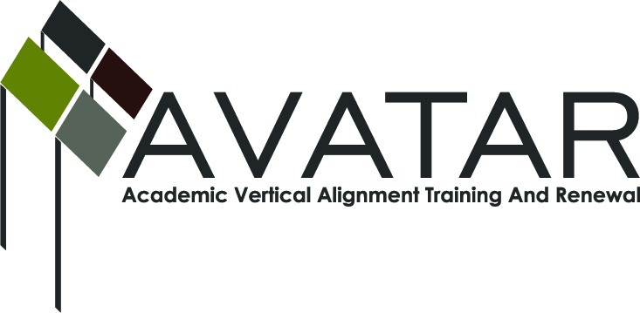
AVATAR Partnership Region: _____15_____________
Meeting/Session Documentation Form

Form should be completed after each meeting and given to the Regional AVATAR Coordinator/Facilitator
Meeting: | May 20, 2014
Meeting Purpose: | College Readiness Course development
Date: | 5/20/14 | Start Time: | 9:00 | End Time: | 3:00
Meeting Coordinator/ Facilitator: | Karan Duwe | Location: |  | Region 15 ESC
Meeting Recorder: | Karan Duwe | Meeting Timekeeper:

Time | Topic | Format | Discussion Leader | Desired Outcome
9:00-9:30 | Review purpose of meeting, answer questions, clarify roles | F | Karan Duwe | Clear misconceptions, readiness for the work
9:45 | Planning | F | Various | Begin work on course development
Agenda Format Key: P = Presentation, F = Feedback, D = Decision-Making, W = Work Group, O = Other, with explanation

AVATAR Meeting Minutes

Action Item | Person Responsible | Due Date
Plan dates for next work meetings | Various | 8/1/14
Notes
Meeting Participant List

Name | Title | Organization/Institution
Karan Duwe | Director | ESC 15
Laura Strube | Associate Director | ESC 15
Traci Terrill | Consultant | ESC 15
Sue Van Hoozer | Consultant | ESC 15
Joyce Sprott | Consultant | ESC 15
Pam Callan |  | Howard College
Susan Strickland | Instructor | Howard College
Roster attached:

