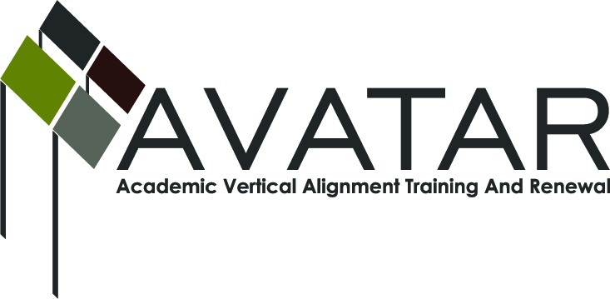
AVATAR Partnership Region: 2
Meeting/Session Documentation Form

Form should be completed after each meeting and given to the Regional AVATAR Coordinator/Facilitator
Meeting: | AVATAR Team Meeting
Meeting Purpose: | Information Meeting
Date: | June 8, 2016 | Start Time: | 3:30 p.m. | End Time: | 4:50 p.m.
Meeting Coordinator/ Facilitator: | Janet M. Cunningham | Location: |  | Peoples Restaurant
Meeting Recorder: | Janet M. Cunningham | Meeting Timekeeper: |  | Connie Nowell

Time | Topic | Format | Discussion Leader | Desired Outcome
3:30 | Welcome | Discussion | Janet Cunningham
3:40 | Review of Spring Exam | Discussion | Janet Cunningham
3:55 | Math Workshop | Discussion | Bethany Goralczyk
4:00 | Professional Development | Discussion | Janet Cunningham/  Tammy Donaldson
4:10 | AVATAR Final Report | Discussion | Janet Cunningham
4:15 | MOU | Discussion | Janet Cunningham

AVATAR Meeting Minutes

Action Item | Person Responsible | Due Date
Welcome: Dr. Cunningham welcomed members.
Review Spring 2016 CPC Math Exam: Review of data from four schools giving assessment and percentage of students, question by question, who passed. Questions where students had difficulties were discussed. Possibility of hosting a workshop for teachers who will teach next semester’s course was discussed, along with information to be disseminated at said meeting. Time and venue of meeting was discussed.
Math Workshop: Bethany Goralczyk discussed details of the math workshop to include discussion of syllabus, timeline of yearly events, results of fall assessment. A basic game plan for teaching the class was begun.
Professional Development:
Math: Decided that teachers of course should be brought together to discuss syllabus, assessments, and course procedures.
ELA: Creation of supplemental material with training and textbook. Information still on-line for upcoming year.
AVATAR Final Report: Dr. Cunningham reported that she would be making her final report to AVATAR. It was discussed that the Advisory Council needs to find some way to continue to meet to create new assessments for each year.
MOU: Dr. Cunningham will obtain a list of participating districts from Melissa Morin next week. We are getting closer to signing CBC. Something should be planned for district counselors/advisors regarding purpose of course, how it will affect students who take the course, etc.
Stipends: Stipends were delivered to meeting participants.

Notes

Meeting Participant List

Name | Title | Organization/Institution
Dr. Janet M. Cunningham | Executive Director | E2E Partners (P-16 Council)
Bethany Goralczyk | Assistant Math Instructor | Del Mar College
Elsa Brown | Math Instructor | C Math is Easy
Steven Mendoza | Secondary Mathematics Specialist | ESC-2
Tammy Donaldson | Reading/ELA Instructor | Del Mar College
Melana Silva | Curriculum Director | Calallen ISD

