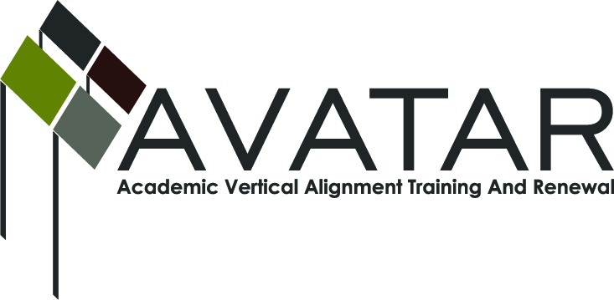
AVATAR Partnership Region: 2
Meeting/Session Documentation Form

Form should be completed after each meeting and given to the Regional AVATAR Coordinator/Facilitator
Meeting: | AVATAR Team Meeting
Meeting Purpose: | Follow up on Math Symposium and discussion of next steps
Date: | April 11, 2013 | Start Time: | 7:30 a.m. | End Time: | 8:40 a.m.
Meeting Coordinator/ Facilitator: | Janet M. Cunningham | Location: |  | Northwest Center for Advanced Studies
Meeting Recorder: | Janet M. Cunningham | Meeting Timekeeper: |  | Connie J. Nowell

Time | Topic | Format | Discussion Leader | Desired Outcome
7:30 a.m. | Welcome | Discussion | Janet Cunningham
7:35 a.m. | Mathematics Symposium | Discussion | Janet Cunningham
7:55 a.m. | Follow-up meeting April 17 | Discussion | Janet Cunningham | Set agenda
8:10 a.m. | “Next Steps” | Discussion | Janet Cunningham | Set plans for next year
8:30 a.m. | Next Meeting | Discussion | Janet Cunningham | Set date
Agenda Format Key: P = Presentation, F = Feedback, D = Decision-Making, W = Work Group, O = Other, with explanation
AVATAR Meeting Minutes

Action Item | Person Responsible | Due Date
Math Symposium:

The evaluations from the symposium show that it was very well received. Had 50 participants. Trainers got very high marks. Lunch worked well.

Should the name be changed for next year’s symposium to something regarding “easing the transition” of students?

Changes: Possibly have two sessions next year – morning/afternoon – and let participants choose. Should have bigger room, a more specific evaluation for each topic, evaluations in packets to be filled out as symposium progresses. Would be better to have symposium in January or February, certainly before spring break.

The morning session should be more generic to include all area institutions.

Follow up meeting on April 17: Melissa to send list of symposium attendees to Dr. Cunningham who will send out a “reminder” email. Start with overview of each session to be followed by general discussion. Dr. Cunningham will compile list of pre-scripted questions to spark discussion. | Melissa Morin/Janet Cunningham | April 15, 2013
“Next Steps” – discussion on what should happen next and when. Group to continue with math discipline. Team for next year to include those now on team plus the possible addition of surrounding school districts. Training for next year’s members could be included in “Me By The Sea” (June 14, TAMU-CC). | Janet Cunningham
The next meeting will be April 17 at 1:30 p.m. at the Service Center for the symposium follow up and then again on Wednesday, May 22, at 7:30 a.m. at NCAS.
Meeting Participant List

Name | Title | Organization/Institution
Dr. Melana Silva | Curriculum Specialist | Calallen ISD
Paul Johnson | Math Instructor | Del Mar College
Melissa Morin | Consultant | ESC-2
Dr. Janet M. Cunningham | Executive Director | Coastal Bend Partners for College and Career Readiness (P-16 Council)

