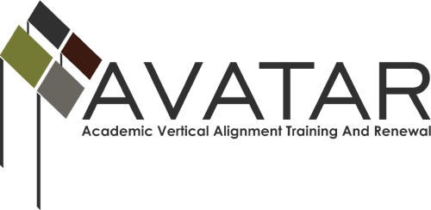

Mid-term Status Report – May 2015 to March 2016

ESC Region ___8___

Date of this report - April 15, 2016

Due on or Before April 15, 2016

- Members of Partnership
- Please list all partnership team members (leaders in the organizations you are working with on alignment projects) by name, affiliation, title, email and phone number, or confirm that all are correctly listed on the AVATAR website by checking here. ___

Name | District/University | Title | Email | Phone
Melisa Jones | Texarkana College | Coordinator for Developmental Education | Lisa.jones@texarkanacollege.edu | 903-823-3223
Dr. Tonya Hill | Texas A&M Texarkana | Director of TRIO Student Support Services | Tonya.hill@tamut.edu | 903-334-6656
Sandra Shingleur | Workforce Solutions of Northeast Texas | Workforce and Education Training Project Manager | Sandra.shingleur@netxworks.org | 903 – 794-9490 Ext 506
Stephanie Sparks | DeKalb ISD | Assistant Superintendent | Stephanie.sparks@dekalbisd.net | 903-667-2566

- Please identify members of your active Vertical Alignment Teams (faculty and staff who are engaged in the actual alignment work) with name, affiliation, title, e-mail address, and phone number, or confirm that all are correctly listed on the AVATAR website by checking here. ____

Name of VAT - College Preparatory Courses_________________________
Name | District/University | Title | Email | Phone
Pam Owney | Texarkana College | English Professor | Pamela.owney@texarkanacollege.edu | 903- 823-3365
Monica Davis | Texarkana College | Math Professor | Monica.davis@texarkanacollege.edu | 903-823-3313
Dr. Catherine Howard | Texarkana College | Dean of STEM | Catherine.howard@texarkanacollege.edu | 903 -823-3285
Pam Montgomery | DeKalb ISD | Math Instructor | Pam.montgomery@dekalbisd.net | 903-667-2422
Lori Shelton | DeKalb ISD | English Instructor | Lori.shelton@dekalbisd.net | 903-667-2422
Lea Dooley | DeKalb ISD | Counselor | Lea.dooley@dekalbisd.net | 903-667-2566

Name of VAT____________________________
Name | District/University | Title | Email | Phone

Name of VAT____________________________
Name | District/University | Title | Email | Phone

- 2015-16 Goals of the Partnership. Please note any modifications from the Action Plan or indicate “none.”
The only modifications have been changes to meeting dates. Our first meeting was scheduled for March, but actually occurred in April.

- Status of Plan of Work

Please list the objectives associated with your 2015-16 goals in the table below and state the activities that have taken place since December 31, 2015, to further each objective. State the results of each activity and any follow-up actions required to meet your objective.

Objectives | Activities | Results/Impact and Follow-up Anticipated
Increase knowledge and understanding of College Preparatory Courses among ISDs through the ISD, post-secondary, and workforce partnerships. | Professional Development in June
Develop a common documentation system for notation of College Preparatory Course completion on high school transcripts and reporting system for course data. | Meeting in May
Develop vertical alignment documents, teacher resources, and a share point for College Preparatory ELA and Math partners. | Meeting in April

- What are the major challenges or obstacles you have encountered since December, 2015, and what have you done to overcome them?
Scheduling a time for all partners and the vertical alignment team to meat has been the most challenging parts so far.
The first meeting that was scheduled for March did not take place until April, which will move all the other dates too.
- What are the dates of your major upcoming events if not stated in the table above?
The next partnership and VAL meeting will be in May.
The professional development will be scheduled in June.

