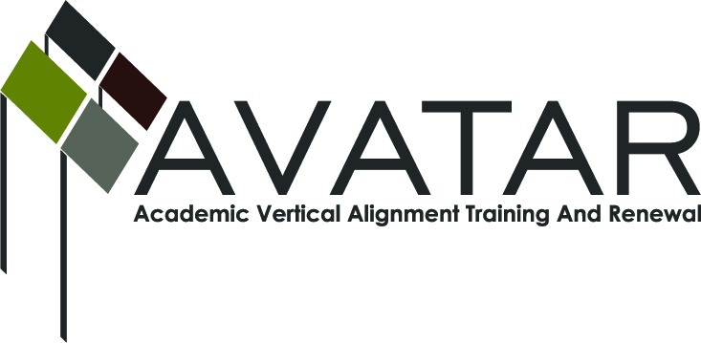
AVATAR Partnership Region: 9
Meeting/Session Documentation Form

Form should be completed after each meeting and given to the Regional AVATAR Coordinator/Facilitator
Meeting: | ELA-AVATAR Team
Meeting Purpose: | ELAR discussion and planning
Date: | 10-8-2012 | Start Time: | 3:40p.m. | End Time: | 5:00p.m.
Meeting Coordinator/ Facilitator: | Kathy Harvey/Joe Johnston | Location: |  | Region 9 Education Service Center
Meeting Recorder: | Kathy Harvey | Meeting Timekeeper: |  | Kathy Harvey

Time | Topic | Format | Discussion Leader | Desired Outcome
3:40-4:20 | Introduction of Team discussion of post-secondary article on college readiness | P, F | Joe Johnston | Open dialogue between secondary and post-secondary team members
4:20-4:35 | Listing differences between secondary and post-secondary expectations | F, W | Joe Johnston | Create ways to change students’ thinking that college is compulsory, but ability isn’t  Look at why AP students take risks in their thinking
4:35-5:00 | Secondary teachers shared constraints of grading/graduation requirements such as EOC and 4x4 | F, Discussion | Misti Spear  Yvonne Baker-Kistler | Students need to learn 1) social responsibility 2) personal responsibility and 3) teamwork. Our plan must assist them with these skills
Agenda Format Key: P = Presentation, F = Feedback, D = Decision-Making, W = Work Group, O = Other, with explanation

AVATAR Meeting Minutes

Action Item | Person Responsible | Due Date
Ideas for focus of ELA team. What is a “best product or service” for students in our region. Secondary will bring graduation /career information to the table. Post-secondary will explore number of transfers from local or other institutions. | All team members | Nov. 7, 2012
Notes

Meeting Participant List

Name | Title | Organization/Institution
Kathy Harvey | Facilitator | Region 9 Education Service Center
Joe Johnston | Team Leader | Vernon College
Jessica Sutherland | P-16 Rep | Vernon College
Greg Fowler | Division Chair | Vernon College
Denise Sanders | Dual Credit Teacher | Vernon High School
Kristen Garrision | Writing Program Admin | Midwestern State University
Sandra Scheller | Dual Credit Teacher | Rider HS-WFISD
Yvonne Baker-Kistler | AP Teacher | Rider HS-WFISD
Misti Spear | Curriculum Specialist | WFISD

