College Transitions: Integrated Reading, Inquiry, & Writing
SAMPLE SYLLABUS
Instructor:
Phone:
Email:

Course Description
College Transitions is designed to help a student develop an awareness of his/her reading, research, and writing processes and adapt them to college contexts. The course will specifically help students develop as engaged, critical readers; strategic researchers; and rhetorical writers who can address a variety of situations and audiences with effective forms and language.

Objectives
In order to better prepare you for the types of reading, inquiry, and writing you will be doing in college, RGV colleges and universities designed College Transitions-Integrated Reading, Inquiry, and Writing to do two things. One, we want to make you more aware of your reading, research, and writing processes so that you can successfully adapt them from high school to college classrooms. Two, we want to help you work with different types of texts, different types of learning situations, and different types of writing choices concerning your message, audience, and form. You will do this by working through a sequence of six six-week sequences that involve reading, writing, feedback, and revision.
Doing this work will specifically help you succeed in your first required college English course, often called Comp 1, Rhetoric & Composition 1, or First Year Writing. For that reason, we are using the student learning outcomes for an integrated college reading/writing class that students usually take after high school but before their first credit-bearing first year reading and writing class. Specifically, this course will improve a student’s ability to:
- locate explicit textual information, draw complex inferences, and describe, analyze, and evaluate the information within and across multiple texts of varying lengths;
- comprehend and use vocabulary effectively in oral communication, reading, and writing;
- identify and analyze the audience, purpose, and message across a variety of texts;
- describe and apply insights gained from reading and writing a variety of texts;
- compose a variety of texts that demonstrate reading comprehension, clear focus, logical development of ideas, and use of appropriate language that advance the writer’s purpose;
- determine and use effective approaches and rhetorical strategies for given reading and writing situations;
- generate ideas and gather information relevant to the topic and purpose, incorporating the ideas and words of other writers in student writing using established strategies;
- evaluate relevance and quality of ideas and information in recognizing, formulating, and developing a claim;
- develop and use effective reading and revision strategies to strengthen the writer’s ability to compose college-level writing assignments; and
- recognize and apply the conventions of standard English in reading and writing.
What you don’t see here are outcomes that only mention one area of study, like writing, for instance. How we read, how we work with other sources of information, how we communicate, and how we compose messages are really complicated and connected processes. As a group, then, these outcomes address the integrated or overlapping abilities needed to be a successful reader, researcher, and writer in college classrooms. These outcomes are also in alignment with high school TEKS for English III and College and Career Readiness Standards, as the chart below shows.
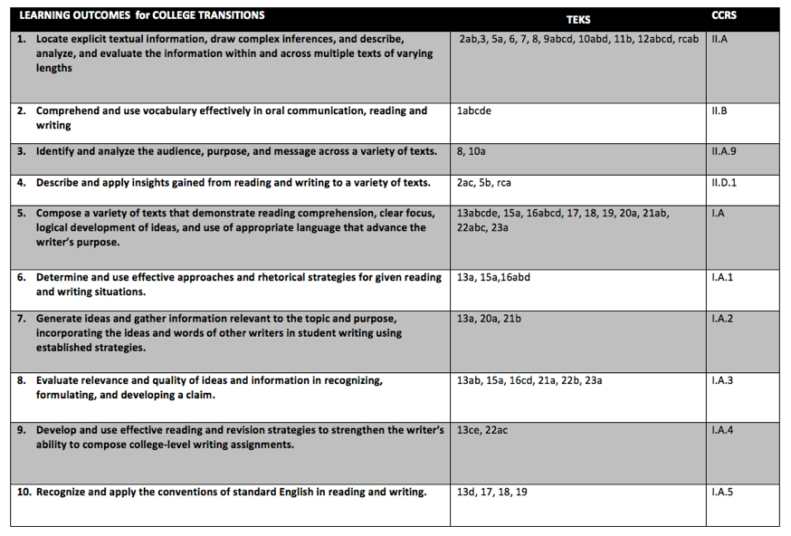

Required Texts
The required text is the iBook College Transitions-Integrated Reading, Inquiry, and Writing. Students can find it and download it through iTunes by searching for the title. It is also available as a PDF. Within College Transitions, each chapter will use readings that are freely available online. Instructors may also require supplemental readings.

Grades
In order to be considered college ready in reading and writing at designated RGV colleges and universities, you will need to have an overall grade for the term of 70 or higher and a 70 or higher on the portfolio.

Suggested Grading Breakdown
MAJOR WRITING ASSIGNMENTS (40% EACH)
There are six major writing assignments, one for each six weeks.
1. Mapping Your Literacy History Profile
2. Working with Audiences
3. Writing in Action
4. Reading, Inquiry, & Writing in College Contexts
5. Reading, Inquiry, & Writing in Your Future Career
6. Preparing Your College Transitions Portfolio Reflective Essay

Each six weeks, you will work on your major writing assignment--drafting, seeking feedback, revising, and editing--until you have an assignment at the end of the six weeks that will receive a grade. This revised assignment grade will count for 40% of your six weeks grade.

Revision is a very important element of this class. Based on teacher guidelines, you will be revising several of your previous major writing assignments even after each six weeks is over. At the end of the semester, you will turn in these revised major writing assignments in a portfolio.

DAILY CLASSWORK (60%)
Classwork may include reading assignments; research assignments; shorter writings, like journals, summaries, and responses; presentations; and other miscellaneous assignments that contribute to your major writing assignment for each six weeks. Combined, the graded daily classwork will count for 60% of your six weeks grade.

Materials
Instructor prerogative

Instructional Technology
Instructor prerogative

Attendance
School guidelines

Classroom Management
School guidelines

College Transitions: Integrated Reading, Inquiry, & Writing
Tentative Six Week Schedule
Sequence 1 - Mapping Your Literacy History

How are we learning to read, inquire, and write as we prepare for college work?

For this sequence, we will do the following work:

- Survey and mapping activity
- Map self-assessment; peer and teacher feedback
- Reading(s), written responses, and discussion
- Deborah Brandt’s “Sponsors of Literacy” http://wac.appstate.edu/sites/wac.appstate.edu/files/brandtsponsors10001-1.pdf
- Alyssa Battista’s “Personal Literacy History” (Prezi with Text, Image, and Movement) http://prezi.com/-1lxsgwx6uha/my-personal-literacy-history/
- Donald M. Murray’s “All Writing Is Autobiography” http://writing.colostate.edu/files/classes/8362/File_2EB4611A-EF85-76EE-E2878652D6EFB7AA.pdf
- Discuss assignment and write draft
- Self-assessment and peer feedback
- Teacher feedback and conference
- Revision of draft in terms of feedback, especially purpose, audience, and form
- Teacher’s 6 weeks evaluation of latest draft and development

Week 1 - Sequence Introduction and Mapping Activity
Day 1 Survey; Intro to Mapping project; Q&A

Day 2 Informal research and discovery: students use their technology (or a computer lab) to research maps and infographics. By the end of the class, students will have created a list of the characteristics and properties that data and narrative maps (like the ones they will be making) have.

Day 3 Mapping, DAY 1: students begin sketching out the elements they want to include in their maps.

Day 4 Mapping, DAY 2: students continue working on their maps and provide feedback/notes on each others’ work.

Day 5 Mapping, DAY 3: students finalize their maps and think about the ways they could “translate” their maps into other media (like websites, podcasts, videos, lectures) — the instructor may choose to revisit the mapping activity later in the year, and have the students formally “build” the translations of their maps.

Week 2 - Readings
Day 1 In Class Reflection on Reading Topic; HW Reading 1 Summary/Response

Day 2 Discuss Reading 1; HW Reading 2 Summary/Response

Day 3 Discuss Reading 2: HW Reading 3 Summary/Response

Day 4 Discuss Reading 3; HW Review Readings and Summary/Responses; Write Reflective Synthesis

Day 5 Interactive Reading Activity: How could you create a literacy documentary of your high school, your class (junior, senior), or your English class? In groups, write develop quick screenplays and mock ups of what a scene from a documentary film would look like. We’ll ask several groups to share.

Week 3 - Assignment and In Class Writing
The instructor should meet informally with each student to get a feel for what each student is accomplishing. Also, if the instructor notices that many students are struggling with the same or similar concepts, the instructor should pause the class and have a mini-lesson on that concept or skill.

Day 1 Writing: draft one (TIP: early draft one is usually super messy, and looks more like ideas, and isolated sentences than an essay. Make sure you are using your map from Week 1 to help you organize this essay.)

Day 2 Writing: draft one (TIP: the writing you have at the end of today might not look too much better than it did on DAY 1, but there will be more of it!)

Day 3 Writing: draft one (TIP: around the third day of this kind of assignment, your writing will likely look and sound more like an essay.)

Day 4 Writing: draft one (TIP: today is a great day to look at your work’s organization — are you saying everything you wanted to? are you saying it in the right order? Feel free to experiment with style and structure.)

Day 5 Writing: draft one // By Monday, students should have a complete first draft to participate in self assessment and peer workshop. Whatever hasn’t been accomplished during class is homework over the weekend. After a week of writing, student first drafts should still demonstrate significant effort. The average draft will likely be 2-4 double-spaced pages.

Week 4 - Self Assessment and Peer Workshop
There are a variety of peer feedback structures and strategies. As long as students are receiving meaningful, instructive, and valuable feedback, it may be helpful to change the structure of the feedback (one-on-one, clocking, groups, etc.) so that the students do not become either bored or complacent. Any time students are doing feedback, the instructor should monitor the advice, affirming when students give good, specific advice, and drawing out deeper feedback when the students give vague or non-actionable advice.

Day 1 Self assessment (pre-peer feedback); peer feedback

Day 2 Peer feedback

Day 3 Peer feedback

Day 4 Peer feedback

Day 5 Self assessment (post-peer feedback); revision plan

Week 5 - Revision and Teacher Feedback
This week, the instructor will meet with each student to provide one-on-one feedback (in later weeks, the students may be skillful enough to handle this in small group settings). It will probably be necessary to set a timer for each meeting, or else all students may not be able to have their own conference. (Students who are willing to schedule their conferences before or after school might help free up how tight the in-class conference schedule is.) While students are not having their personal conference, they should be working on their revision, writing draft two.

Day 1 TEACHER CONFERENCE; Writing: draft two, revision (TIP: one of the hardest things writers have to do is let go of the parts of their writing that just isn’t working. On the first day of revision, you should re-examine your essay and identify, using the feedback from your peers and teacher, what is and isn’t working in your paper. How can you fix it?)

Day 2 TEACHER CONFERENCE; Writing: draft two, revision (TIP: don’t try to fix everything all at once. Pick one element or aspect or location in your paper, and only work on that today.)

Day 3 TEACHER CONFERENCE; Writing: draft two, revision (TIP: don’t try to fix everything all at once. Pick one element or aspect or location in your paper, and only work on that today.)

Day 4 TEACHER CONFERENCE; Writing: draft two, revision (TIP: don’t try to fix everything all at once. Pick one element or aspect or location in your paper, and only work on that today.)

Day 5 TEACHER CONFERENCE; Writing: draft two, revision (TIP: take time to re-read and listen to your revision. Does it look better, sound better, feel better than draft one? What did you end up changing? Are those things specific to only this paper? Or can you generalize what you did to any of the other written work you do this year?)

Week 6 - In Class Revision and Six Weeks Assessment
For the peer revision this week, try larger or whole-class strategies (like clocking or revision in small groups or even mix and match).

Day 1 Peer feedback

Day 2 Peer feedback

Day 3 Writing, DAY 1: draft three, revision (TIP: One focus of this round of revision is style, linguistic etiquette, and overall making sure it looks good. Make sure your paper is wearing a suit and not flip flops.)

Day 4 Writing, DAY 2: draft three, revision

Day 5 Portfolio assessment: So far, will this piece be part of your final portfolio? Why or why not? What further revision could you do to feel more comfortable with this piece being part of your final portfolio? What was most difficult about accomplishing this particular writing task? What lessons or knowledge will you take to the next project to make sure it goes more smoothly for you?

