A membership organization committed to promoting and celebrating
excellence in teaching, learning, and leadership at community and technical colleges.
- Home
- Membership
  - Join NISOD
  - Member Benefits
  - Member Colleges
  - Ways to Engage With NISOD
  - Student Art Contest
  - Scott Wright Student Essay Contest
  - FAQ
  - Testimonials
  - Liaison Resources
- Conference
- Exhibitors/Sponsors
  - Exhibitor/Sponsor Registration
  - Exhibit Hall and Schedule
  - Exhibitor and Sponsor Marketplace
  - Sponsorship and Advertising
  - Prospectus
  - FAQ
- Excellence Awards
- Webinars
- Publications

P-16 Statewide Professional Development Pre-Conference
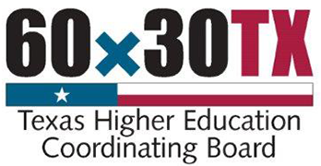​ 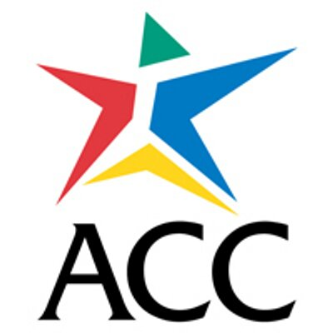
The Texas Higher Education Coordinating Board and Austin Community College, in partnership with NISOD, is hosting the first annual P-16 Statewide Professional Development Pre-Conference on May 28, 2016, in conjunction with NISOD’s 2016 International Conference on Teaching and Leadership Excellence. Both events will take place at the Hilton Austin. (See lodging information below.)
The P-16 Statewide Professional Development Pre-Conference offers access to national and regional speakers and program resources to address topics related to transitioning students from secondary to postsecondary education. The pre-conference will engage participants in informative breakout sessions and exceptional networking opportunities. Don’t miss this opportunity to explore and exchange models of practice and evidence-based strategies focused on specific topics that include:
- Dual enrollment, early college high school, and other pre-college options
- Improving students’ financial literacy
- Streamlining P-16 pathways to college success
- High school and college academic advising
AGENDA
8:30 - 9:00 AM | Registration and Continental Breakfast
9:00 - 9:45 AM | Welcome and Introductions
10:00 - 11:00 AM | Sessions 1 - 4
11:15 AM - 12:15 PM | Sessions 5 - 8
12:30 - 1:30 PM | Lunch and Keynote Presentation (Dr. Mark David Milliron)
1:45 - 2:45 PM | Sessions 9 - 12
3:00 - 3:30 PM | Closing and Adjourn
This inaugural P-16 Statewide Professional Development Pre-Conference is designed for high school counselors, admissions advisors from two-year and four-year institutions, and other educators interested in learning more about college access and success across Texas. NISOD’s annual conference is the definitive gathering of community and technical college educators seeking best and promising practices designed to improve student achievement. Educators can participate in either or both events by registering below. Your P-16 Statewide Pre-Conference registration fee includes continental breakfast, keynote presentation lunch, and breakout sessions. Space is limited and previous THECB meetings have sold out quickly. So, you are strongly encouraged to register and secure your lodging as soon as possible.
REGISTRATION
P-16 Statewide Professional Development  Pre-Conference Only  (Prior to April 15) | P-16 Statewide Professional Development  Pre-Conference and NISOD Conference  (Prior to April 15)
$150 | $629 (which is a $50 conference discount)
Register | Lodging
Call for Presentations
The THECB, ACC, and NISOD are currently accepting proposals to present sessions at the P-16 Statewide Professional Development Pre-conference. Ideal proposals will share promising and evidence-based practices that address topics including:
- Dual enrollment, early college high school, and other pre-college options
- Improving students’ financial literacy
- Streamlining P-16 pathways to college success
- High school and college academic advising
Breakout sessions will be 60 minutes including time for questions. Laptops will be available upon request. We invite you to submit proposals for review to Claudette.jenks@thecb.state.tx.us by March 2, 2016.

About The Texas Higher Education Coordinating Board
The Texas Higher Education Coordinating Board provides leadership and coordination for the Texas higher education system. Since being created by the Texas Legislature in 1965, the Board has worked to achieve excellence for the college education of Texas students. The Texas Higher Education Coordinating Board promotes access, affordability, quality, success, and cost efficiency in the state’s institutions of higher education, through Closing the Gaps and its successor plan, resulting in a globally competent workforce that positions Texas as an international leader in an increasingly complex world economy.
About Austin Community College
Austin Community College is a nationally recognized two-year college serving Central Texas. ACC is focused on student success and providing affordable, flexible pathways to help students reach their education goals, learn new job skills, or advance their career. The college currently enrolls more than 43,000 credit students and serves an additional 15,000 students each year through noncredit programs.
About NISOD
The 2016 International Conference on Teaching and Leadership Excellence is hosted by NISOD, a membership organization committed to promoting and celebrating excellence in teaching, learning, and leadership at community and technical colleges. For community and technical colleges that want to make the most of their professional development dollars, NISOD provides budget-friendly, high-quality, and faculty-focused programs and resources. For nearly 40 years, NISOD’s customer-focused approach has helped align our wide array of benefits with the needs of our members.

Navigation
- Home
- Membership
- Conference
- Exhibitors/Sponsors
- Excellence Awards
- Webinars
- Publications

Recent Articles

This week's issue of Innovation Abstracts is now available!
published 6 hours 24 min ago

Dr. Gail O. Mellow to Keynote NISOD’s 2016 Conference
published 1 week 3 days ago

NISOD to Celebrate 25th Anniversary of Excellence Awards
published 2 months 1 week ago

NISOD Direct Sign Up
published 2 months 3 weeks ago

2016 Scott Wright Student Essay Contest Announcement
published 4 months 1 week ago

Community Colleges Recognize Their Outstanding Faculty, Administrators, and Staff
published 1 year 12 months ago

Recent Tweets

Search NISOD:

Search

Follow Us
NISOD

